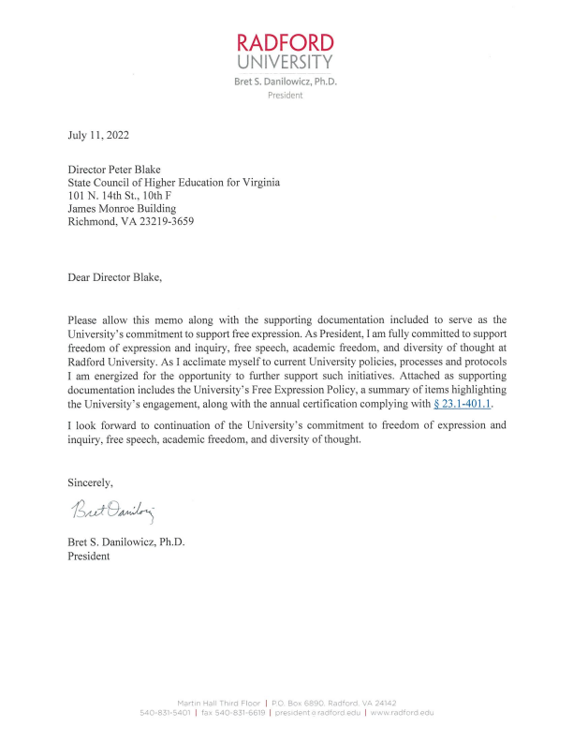
Policy Title: Free Expression Policy | Effective Date: 6/18/2014
Policy Number: GEN-PO-1007 | Date of Last Review: 2/1/2022
Oversight Department: Office of the President | Next Review Date: 2/1/2025

1. PURPOSE
The Free Expression Policy for Radford University (University) provides a framework for a safe and supportive environment to promote free expression. The purpose of this policy is to promote and facilitate free expression, provide a secure environment for such expression, preserve order within the University community, and protect and preserve University property.
2. APPLICABILITY
The Free Expression Policy applies to any person, group, entity, or organization desiring to invoke their rights to freedom of expression on University property.
3. DEFINITIONS
Affiliated Entities: University colleges, departments, and offices; University registered student clubs and organizations; and University employees and students.
Commercial Activity: Communicative conduct or activity on behalf of a company or person for the intent of making a profit. Such activity is economic in nature and usually has the intent of convincing a person or group to partake in a particular economic action such as purchasing a product or service.
Free Expression Activity: For the purposes of this policy, communicative conduct or activity protected by the First Amendment including, but not limited to, public speeches, demonstrations, marches, protests, and picketing. Free expression activity does not include commercial activity.
Spontaneous Expression: Any lawful free expression activity that:
• is prompted by news or affairs coming into public knowledge less than forty-eight (48) hours prior to such activity;
• is not planned more than twenty-four (24) hours in advance;
• takes place in open, generally accessible outdoor areas on University property; • adheres to time, place, and manner requirements as set forth in section 5.C.
Unaffiliated Entities: Businesses, organizations, groups, or persons not affiliated in an official capacity with the University.

University Property: All land, buildings, facilities, and other property owned, leased, or controlled by the University.
University Community: For the purposes of this policy, all persons who are employees, students, contractors, volunteers, and visitors, including invited guests, of the University.
4. POLICY
A. The University celebrates the right to freedom of expression on University property. Free inquiry and free expression are indispensable to the vibrancy and vitality of the University community. The University values and honors diverse perspectives and believes opportunity should be provided to engage in peaceful and orderly protests and demonstrations.
B. Federal, state, and local laws and regulations, as well as University policies, procedures, and standards of conduct, if applicable, must be observed and followed. The University does not permit expression that is unlawful or otherwise prohibited by law. Such expression includes, but is not limited to, defamation, incitement to unlawful conduct, imminent threats of actual violence or harm, obscenity, fighting words, copyright or trademark violation, criminal or civil harassment, sexual harassment, trespass, and false advertising.
C. The right to freedom of expression includes the right to dissent, but these rights need not be exercised in the same forum at the same time. Intentionally or substantially interfering with the freedom of expression of others under this policy is prohibited. Responsible dissent requires sensitivity for the civil rights of others.
D. While the University is a public institution of higher education, the University has the power to preserve University property for the use to which it is lawfully dedicated. Therefore, the University will only make its property available to non-students or non-employees as provided under this policy.
E. In addition to persons authorized by University policy, the Radford University Police Department, and other law enforcement agencies acting pursuant to a mutual aid agreement or by concurrent jurisdiction, are lawfully authorized to enforce this policy as necessary. All persons must comply with the directions of such authorized persons acting in the performance of their duties.
F. The University reserves the right to deny, cancel, or terminate any free expression activity for violations of this policy. Violations of this policy may be subject to disciplinary action as appropriate.
G. Complaints regarding alleged denial of free expression rights shall be reported to the Office of Institutional Equity.
5. PROCEDURES
A. Advance Notification
1. Advance notification is not required for spontaneous expression (see Definitions in section 3.) by affiliated entities. However, if the spontaneous expression activity grows substantially, then notification by any participant, or other member of the University community aware of the activity, is encouraged. Such notification should be made by calling the University Scheduling Office (540-831-7000) during business hours, or the University Police (540-831-5500) during nonbusiness hours including weekends.
Free Expression Policy Page 2 of 5

2. For all other free expression activity, affiliated entities and sponsored unaffiliated entities (see section 5.B.) are required to provide advance notification to the University Scheduling Office (540-831-7000) a minimum of forty-eight (48) hours prior to any free expression activity on University property. Any University facilities that are required to be scheduled must comply with the Use of University Facilities Policy.
3. In deciding whether a free expression activity is spontaneous or planned, the University may consider any relevant evidence including, but not limited to, whether:
a. signs or placards used are commercially produced;
b. amplification equipment is used;
c. timing of any contact with security or the media; or
d. other circumstances demonstrate advance planning by one or more organizations.
4. Advance notification is intended solely to ensure that the exercise of free expression on University property is conducted in a manner that promotes the safety of the University community; does not interfere with the operation of the University; complies with federal, state, and local laws; and protects the rights of others.
5. Advance notifications must include the following information:
a. Date and time of the activity
b. The location of the activity
c. A brief description of the activity including the names of any unaffiliated entities involved, if applicable
d. Name of the affiliated entity sponsoring the activity
e. Primary contact information of the affiliated entity
f. Request for use of sound amplification, if applicable
g. Estimated number of attendees
h. Acknowledgement of, and agreement to comply with the time, place, and manner requirements as set forth in section 5.C. below.
B. Sponsorship of Unaffiliated Entities
1. In order to engage in free expression activities on University property, unaffiliated entities must be officially sponsored by one of the following entities:
a. University college, department, or office; or
b. University registered student club or organization (see Clubs and Organizations).
2. Unaffiliated entities, not sponsored by one of the entities above, that are exercising free expression activities on University property will be advised that they are trespassing and will be asked to leave University property.
C. Time, Place, and Manner Requirements
1. Free expression activity within any building on University property must take place only during the normal operating hours of the building.
Free Expression Policy Page 3 of 5

2. Additionally, free expression activity on any University property must not: a. attract a crowd larger than the location can safely contain.
b. significantly disrupt University educational or administrative activities inside or outside of buildings, including classes.
c. significantly disrupt previously scheduled University ceremonies or events.
d. obstruct free passage of any person or persons (e.g. entrances or exits to buildings, vehicular or pedestrian traffic, etc.). Illegal obstruction is a violation of Virginia Criminal Law (Code of Virginia § 18.2-404).
e. represent a threat to public safety, according to the discretion of the Chief of University Police.
f. include camping or the use of temporary shelters (e.g. tents).
g. affix items to any permanent structure (i.e. fences, buildings, trees, etc.).
h. light any material on fire, except hand-held candles may be used upon receiving written permission from the Office of Environmental Health and Safety. Bonfires and other open flame devices are strictly prohibited.
3. The use of sound amplification on University property must comply with the Use of University Facilities Policy and must not disrupt the educational and administrative activities of the University.
4. The University reserves the right to assign a location, or relocate to a more appropriate location, any free expression activity due to potential concerns with any of the above time, place, and manner requirements.
6. EXCLUSIONS
This policy does not apply to posting, chalking, or the distribution of informational materials, which are covered by the Posting, Chalking, and Distribution of Informational Materials Policy.
This policy also does not apply to sales and solicitation activities covered by other University, divisional, and/or departmental policies.
7. APPENDICES
None
8. REFERENCES
Code of Virginia § 18.2-404, “Obstructing free passage of others.”
Code of Virginia § 23.1-400, “Student organizations; rights and recognition.”
Code of Virginia § 23.1-401 et seq., “Restrictions on student speech; limitations.”
9. INTERPRETATION
The authority to interpret this policy rests with the President of the University and the President’s Cabinet.
Free Expression Policy Page 4 of 5

10. APPROVAL AND REVISIONS
This new policy was reviewed and approved by the President’s Cabinet on June 17, 2014. President Kyle signed the Free Expression Policy on June 18, 2014.
Effective July 1, 2017, the Free Expression Policy was reviewed by the oversight department and the Office of Policy Compliance. Minor revisions were made and the policy was updated to the current University policy template. No substantive changes were made that would alter the scope or application of the policy.
A revision to the Free Expression Policy was reviewed and approved by the President’s Cabinet on March 26, 2018. President Hemphill signed the revised policy on May 10, 2018.
Reviewed February 1, 2022. Only minor editorial revisions.
For general information concerning University policies, contact the Office of Policy and Tax Compliance – (540) 831-5794. For questions or guidance on a specific policy, contact the Oversight Department referenced in the policy.
Free Expression Policy Page 5 of 5
Radford University Free Speech Engagement
Radford University supports and celebrates free speech at a number of annual events held on campus, notably Constitution Day, Citizenship Week, and Banned Books Week.
Many of the university’s academic programs embed free speech elements in courses and encourage students and faculty to express themselves freely and host First Amendment events. Some examples include the following.
• The Citizen Leader Program requires students to participate in community and civic engagement activities supporting free speech, and local government involvement.
• The School of Communication regularly hosts or participates in panel discussions on free speech and media ethics. In Spring 2022, faculty and students from the Radford University School of Communication and Virginia Tech School of Communication organized an effort to live-stream and record the regional Society of Professional Journalists (SPJ) conference; free speech is regularly featured at the SPJ conferences.
• The Political Science Department includes free speech at their annual Political Science Days and at the Wicked Festival, where students explore and tackle persistent public problems (wicked problems). In addition, political science students travel to Washington, D.C. to learn more about free speech advocacy with interest groups.
• Several organizations and departments coordinated Courageous Dialogue last year to provide a framework for the campus community to engage in meaningful and impactful conversations around social issues.
Several student organizations seek to promote free speech and engage the campus community in civil discourse.
• Over the last two years, a student-led and student-organized event known as the Bigger Picture March was held on campus and members of the administration, faculty, and staff joined students to exercise their free speech and advocate for social justice and societal change (2020 March and 2021 March).

• The Political Science Society encourages healthy debates with differing viewpoints and conducts campus polls on pressing matters; in addition, the Political Science Society and Law Society will host forums and speakers centered on free expression.
• Radford University’s student media organizations are open to all students, including the student-run newspaper, student online magazine, student run radio station, and student literary arts magazine.
November 19, 2021
The Honorable Ralph Northam
Governor of Virginia
Post Office Box 1475
Richmond, Virginia 23218
The Honorable L. Louise Lucas
Chairman of the Senate Committee on Education and Health
Senate of Virginia
Post Office Box 700
Pocahontas Building, Room E604
Richmond, Virginia 23218
The Honorable Roslyn C. Tyler
Chairman of the House Committee on Education
Virginia House of Delegates
900 East Main Street
Pocahontas Building, Room E306
Richmond, Virginia 23218
Dear Governor Northam, Chairman Lucas, and Chairman Tyler:
In accordance with §23.1-401.1 of the Code of Virginia, entitled “Constitutionally protected speech; policies, materials, and reports; report,” Radford University provides this compliance report, as detailed herein.
Radford University’s Free Expression policy provides a framework to promote and facilitate free expression, provide a secure environment for such expression, preserve order within the University community, and protect and preserve University property. The policy further clarified procedures for conducting free expression activities on University Property. In addition, the policy defines the process of reporting incidents of disruption to the Office of Institutional Equity.
Other University policies, such as the Standards of Student Conduct; Use of University Facilities; and Posting, Chalking, and Distribution of Informational Materials Policy; reinforce and support the University’s Free Expression Policy. All University policies may be found at: https://www.radford.edu/content/policies/home.html. Policies are communicated through various communication channels such as e-mail communication, resource cards, and trainings.
P.O. Box 6988, Radford, VA 24142 | 540-831-5307 | www.radford.edu/oie
No complaint has been filed in a court of law since December 1, 2020, to initiate a lawsuit against Radford University, or any employee of Radford University in his or her official capacity, for an alleged violation of the First Amendment to the United States Constitution.
As stated in the Free Expression policy, the University celebrates the right to freedom of expression on University property. Free inquiry and free expression are indispensable to the vibrancy and vitality of the University community. The University values and honors diverse perspectives and believes opportunity should be provided to engage in peaceful and orderly protests and demonstrations.
Sincerely,
Andrea P. Zuschin, Ph.D.
Director of Institutional Equity
cc: Carolyn R. Lepre, Ph.D., Interim President
Chad A. Reed, Vice President for Finance and Administration
Lisa M. Ghidotti, Executive Director of Government Relations
P.O. Box 6988, Radford, VA 24142 | 540-831-5307 | www.radford.edu/oie

