George Mason University 2021 SIX-YEAR PLAN NARRATIVE (Part II)

OVERVIEW
The totality of the six-year plan should describe the institution’s goals as they relate to state goals found in the Pathways to Opportunity: The Virginia Plan for Higher Education; the Higher Education Opportunity Act of 2011 (TJ21); and the Restructured Higher Education Financial and Administrative Operations Act of 2005.

The instructions under institutional mission and alignment to state goals, below, ask for specific strategies, in particular related to equity, affordability and transformative outcomes. Other sections will offer institutions the opportunity to describe additional strategies to advance institutional goals and state needs. Please be as concise as possible with responses and save this narrative document with your institution’s name added to the file name.

SECTION A: Pandemic Impact: Briefly discuss, in one to two paragraphs, how the pandemic has impacted your institution. What things did your institution already have in place that proved helpful? What lessons were learned? What short-term changes have been made? What long-term changes will be made? What are the concerns moving forward?

RESPONSE:

Pandemic’s impact on George Mason University
As Mason underwent the most severe and prolonged duress of its existence, the experience left it forever changed in some respects, while in other respects it confirmed some of the bedrock characteristics of this young and resilient university. Both the change and the constancy we experienced have helped us to understand better who we are and how we may best serve the Commonwealth.

What has changed:
Through more than a year of remote operations, we discovered new ways of working, teaching, conducting research, and living that will remain with us even as the last of the pandemic eventually subsides. In particular:

- Instruction – Where we were largely an on-campus university in March 2020, we learned overnight how to deliver all of our course offerings – up to 10,000 course sections – online. We now are examining where online learning remains the better option regardless of circumstances. As a result, our faculty have new teaching tools, our students have new learning options, and we are no longer so place-bound, extending the possibility of a Mason education to far beyond our traditional base of Northern Virginia.
A pre-pandemic academic question of where we teach – online or on campus? – has been answered. We thrive in both. The question now is what we teach and how we teach it: the quality of the curriculum, its relevance to students’ lives, and the speed and options with which they can access it are the frontier we are exploring.
- Research – We now know our research can move at the speed of necessity when it must. In just months, we developed our own saliva-based COVID test protocols so we could conduct mass-scale testing to keep this sprawling mini-city of 50,000 faculty, staff, students, and visitors as safe as possible. And we developed the Fast Grant system to connect donors with researchers who could stay ahead of the pandemic, contributing to such innovations as the Yale University-produced testing protocol that is credited with saving the NBA.
- Working – We can run a $1.2 billion, 39,000+ student, multi-campus, top research university from a thousand home offices if we must. And even when we don’t have to, we now can leverage time and technology more effectively to create smart work weeks that blend on-campus and online, high-tech and high-touch work techniques. Faculty and staff will always be an on-campus presence for our students, because they come first. But we will likely never be a workforce that must always commute to campus five days a week for eight traditional office hours.

Reducing required commutes will mean more workforce productivity, better work-life balance, a more efficient use of our buildings and grounds, and a reduction in our collective carbon footprint.

What has not changed:
Institutional values, useful motivators to build organizational culture during normal times, are either proven or disproven during times of emergency. Several of our values came to the fore and were central to our successful response to the pandemic. We learned that, even under the most extraordinary of conditions, the following values are not just aspirational, they define who we are:

- Our students come first – Continuity of services and care have held our student body together. We learned how to safely house them, teach them, and feed them (including our famous robots that roam our Fairfax campus delivering food). It appears students have responded with their confidence, because we enrolled and graduated record numbers of students throughout the pandemic, and we are on track to enroll another record headcount in the fall of 2021.

- Diversity is our strength – During the pandemic and the economic crisis it triggered, we also endured a jarring series of racial injustices that would have been traumatic even if they had not happened during the pandemic. With students from communities of color forming a majority of our enrollment, we drew upon our own diversity as a source of strength to manage multiple social traumas at once. We stuck together when other communities were coming apart.

- Innovation is our tradition – We flipped this campus overnight into an institution buffered against the intrusion of COVID – and we did much of this by drawing on what we already had, already knew, or had already planned for. We developed our own rapid-results, mass-testing protocol, converted our basketball arena into one of three Fairfax County mass vaccination sites, and converted our mobile health units into rolling vaccine clinics at work in vulnerable communities. As a result, fewer than 1,000 Mason's students, faculty, staff, and on-campus contractors contracted COVID. None died. And as we write this, Mason has zero confirmed active cases within its community.

- We are careful stewards – Despite the financial stress of Depression-era magnitude, we experienced no major staff reductions or program eliminations, and we project that we will end the fiscal year with a modest fund balance. Careful, constant stewardship allowed us to avoid fiscal catastrophes and service interruptions that other universities unfortunately endured.

- We thrive together – Perhaps the single biggest contributing factor to Mason’s successful navigation through the pandemic was the camaraderie of our students, faculty, and staff. We were all figuring out how to navigate in our respective roles, and we pulled together in moments when the stress may have tempted us to retreat to our respective comfort zones. Mason students were uncommonly serious, focused, and resilient. So were faculty and staff. We leaned on each other to figure out how to get from one day to the next, and from one semester to the next. We truly thrived together.

Lessons Learned:
When Mason’s equilibrium is disrupted, we are remarkably capable of finding a new one. The pandemic challenged every facet of the university’s regular way of functioning but in many ways these challenges allowed Mason to gain a better understanding of many elements and how best to enhance them or leverage them in the future.
We rediscovered that Mason’s deep pool of subject matter experts extended beyond our faculty, who deliver instruction and research, to administrative professional staff with expertise in specific areas like public health, health and safety, emergency and risk management. These experts have built robust external relationships with their counterparts in the region over decades, and these partnerships were key to Mason’s success during the pandemic. And collectively, we found our national voice in this global crisis. Several members of our faculty became vital national experts on the unfolding mystery of this pandemic. In particular, faculty like Lance Liotta of the College of Science, Amira Roess of the College of Health and Human Services, and Saskia Popescu of the Schar School of Policy and Government, became vital fixtures in the national media, explaining innovations in fighting the pandemic, conveying
important means of combatting it and surmising its implications on our future.

Delivering Education:
Whatever the new reality of remote higher education is or means, we are thinking carefully about how best to adapt to the opportunities of digital learning while maintaining the fundamental and foundational strengths of the in-person experience.
Other lessons learned include:

Teaching & Learning:

- Even in a pandemic, we are capable of continuing to deliver teaching and learning.
- Universal course design and a system of delivery that is flexible and resilient will allow us to sustain teaching and learning.
- Remote teaching requires understanding the challenges and limitations of remote learning and working to leverage this new modality.
- Students with the least resources and the most significant barriers to learning were disproportionately disadvantaged.
- HyFlex, a teaching model that gives students a choice of attending in person or online, will require a significant investment to be sustainable at Mason.
- Hybrid student development programming is vital to accommodate both students who are virtual and in-person.

Communication & Training:
- Frequent, regular and anticipatory communication, both internally and externally, are vital when we are teaching and learning remotely.
- Cross-training and involving strong administrative leadership and physician teams are vital to support increased public health responsibilities.
- Clear communication of messages/policies for all audiences is required.
- Cross-training within specific units is very helpful to manage the increased and different type of workload associated with student cases.

Operations:
- Supporting a full complement of remote workers will require significant infrastructure improvement.
- We have many interdependent complex projects to improve efficiency and effective; project management support is critical to be able to implement successfully.
- To build on our pandemic successes, we will require significant investment and improvements in digital systems and processes for our faculty, staff and students.
- Strength and flexibility of major service contracts helps to minimize losses and allows for rapid operational flexibility.
- In order to return to near-normal operations and campus population levels, it was essential to invest in some retail partners to maintain their presence on campus.
- We always worked to maintain a long-term perspective with contractors in spite of short-term crises.
- Ongoing and sharp financial analyses were critical to balancing operational changes and customer service with financial impacts and potential losses.

Short-term changes:
In order to stay ahead of pandemic conditions as the conditions rapidly deteriorated and set in for the long term, we committed to the following:

- Adjusted operations to accommodate student, faculty, and staff campus departures in March 2020.
- Pivoted from on-site operations to fully remote in March 2020.
- Evolved from fully remote to a mixture of in-person, hybrid, as well as synchronous and asynchronous online courses.
- Adjusted services and event operations and downsized to meet reduced demand.
- Adjusted dining operations to match reduced residential student population and implemented a reservation system, daily meals to quarantine/isolation students, and more on-the-go services.
- Enhanced cleaning operations were implemented to meet COVID requirements.
- Successfully reopened operations (on a reduced basis) in August 2020 to meet residential student, staff, and faculty populations on campus.
- Mason stood up COVID diagnostic and surveillance testing and vaccination clinics and testing laboratories will continue to operate in the next academic year and potentially longer, as needed. Mason’s symptom screener and related staff who respond and provide guidance on an individual basis will remain intact in the short-term.
- Emergency and continuity committees will continue to work to adapt policies and procedures as the pandemic continues to evolve.
- Safety training will continue to be held virtually while some sessions begin to be brought back in person.
- Augmented in person medical and mental health care for students with a Telehealth option.
- Established holiday, break, and weekend medical provider on-call coverage. Healthcare providers were trained in COVID protocols including contact tracing, diagnostic testing, rapid COVID testing, continually evolving public health and medical guidelines.
- Multi-departmental teams worked closely together for implementation of isolation and quarantine procedures including procedures for clearance and pre-move-in testing, collaboration with Intercollegiate Athletics for contact tracing, testing, isolation and quarantine.
- Regular, frequent meetings between Mason’s Outbreak Mitigation and Management Team and the Fairfax County Health Department for situational awareness and coordination of potential outbreaks.
- Fiscal processes have been converted to alternate methods in favor of encouraging more electronic payment methods and converting paper processes to electronic forms and distribution.
- Reduced and postponed capital expenditures.
- Expanded security with additional applications placed behind two-factor authentication.
- Changed purchasing patterns in favor of mobile-enabling technologies (i.e., purchasing laptops instead of desktop computers).

Long-term changes needed:
Many of the changes made as short-term solutions will have lasting effects on our long-term operations. Having proven the effectiveness of remote work for many functions, full or part-time telecommuting arrangements are expected to become more widespread, particularly for administrative functions, allowing redeployment of valuable campus space to support academic needs.

Adding interactivity to instruction and events: Future events, including conferences and community engagement sessions, will adopt the HyFlex format, where Mason will accommodate both in-person and remote audiences. Rather than a remote audience passively “watching” an event, they will have the option to interact with the presentation by taking part while getting feedback in real time. Mason is already on this path for some of its courses, so with the help of thoughtful design technology, it is possible to achieve a seamless integration of experiences by facilitating participation between a live and virtual gathering. While a portion of the population is eager to return to in-person instruction, which will remain dominant, Mason also has a significant number of students who respond better with this type of accessibility and flexibility as well as a more dynamic learning environment.

Health and well-being: Regarding public health and safety measures and services, Mason is considering a business model that will enhance employee health and well-being. As an integral element of our public health and safety measures, COVID diagnostic and surveillance testing sites and laboratories will continue to operate for as long as the pandemic warrants after this academic year. If needed, this longer-term effort will likely have a much-reduced footprint and staffing requirements. Lastly, our public health and safety measures will continue to include telehealth services to increase access to healthcare for diverse student and potentially employee populations.

Re-engineering office space and facilities: The university is rethinking the use of its space and facilities. This includes a broad, comprehensive perspective via the Master Plan, including utilization of academic spaces, as well as unit-level usage of office and other spaces. Mason plans to provide and continue technology enhancements to deliver more flexible customer service options for students. For example, the use of touchless dining hall verification via iris scan provides a smoother and safer student experience. We have reinvested in providing services that create a positive attraction to campus for students, faculty, and staff. For example, we have revised some dining operations to be more student friendly, and we are planning for longer-term changes in services to enhance the campus experience.

Other long-term changes include:
- Updated policies related to housing contracts and immunizations.
- Remote meeting technologies via Zoom/MS Teams will continue to be utilized to accommodate meetings between staff despite work locations.
- Mason is deploying a “cashless campus” strategy, which entails enabling more electronic payment options along with payment handling directly by financial institutions. This will improve controls and security by reducing cash handling and increase efficiencies by concentrating payment processing and allowing electronic posting.
- Mason will continue to eliminate manual forms/procedures in favor of streamlined and automated processes that can function effectively regardless of location of staff.

Concerns moving forward:
Behavioral health and well-being: Covid-related concerns include the emerging behavioral health issues for Mason faculty, staff and students, as well as Mason’s ability to help our employees and students manage the residual effects of virtual life and anxiety related to basic health and safety, and social interactions. With the substantial and expected increase in demand for mental health care services when students return in the fall, we need to expand and fund additional campus resources to appropriately support students, faculty, and staff.

Workforce competitiveness: Mason will be challenged to be competitive for high performing researchers, instructors, and administrators, as the workforce norms and facilities continue to evolve to support a new way of learning, working and playing. We anticipate that both current employees and new hires will expect to have the option of expanded remote work opportunities including working from other states or even countries. In addition, current employees will expect that their managers have enhanced skillsets to effectively manage a distributed workforce, to include instilling a common sense of Mason’s culture and norms, teambuilding, and ensuring effective quality and productivity.
While not Mason employees, the pandemic has also affected the workforces of several of our large contractors. As an example, some contractors are having difficulty filling their staffing needs as we move to more normal campus service levels.

Deferred maintenance and long-term financial recovery: We must balance the need to reinvest in deferred capital and maintenance needs with the requirement to replenish financial reserves (partially depleted during COVID). Additionally, some changes brought on by the pandemic may have longer-term financial consequences which are not yet well understood. One such example is that there has been a reduced number of students who have committed to live within Housing and Residence Life for AY 2021-2022. Also related to housing, for at least the next academic year, the university will need to continue to care for and perform the necessary work for the management of students in quarantine and isolation.

Instructional delivery:
It is likely that most universities will not fully return to the traditional procedures of the past and instead will maintain some sort of hybrid teaching and workforce operations, utilizing technology at a greater rate than ever before. As a result of this increase in use, a major concern is having enough infrastructure (hardware and software) to support that demand while providing the necessary security to protect Mason’s data and systems. There are also concerns about Blackboard’s bandwidth and stability given the increased number of users.

Understanding evolving student demands:
Throughout the pandemic, especially toward the end of the Spring 2021 semester, students pled for an increase in face-to-face courses. The University adjusted to meet those requests, but when registration for the Fall 2021 semester opened there was a high demand for online courses rather than those classes that were scheduled for in-person learning. Therefore, one of the largest issues facing faculty and course schedulers is trying to truly understand demands of students for modalities we need to provide in the future. Long-term integration of changes in how we work is also being analyzed and the university needs time to appropriately adjust and restructure operations to provide proper levels customer service.

SECTION B: Institutional Mission, Vision, Goals, Strategies, and Alignment to State Goals: Provide a statement of institutional mission and indicate if there are plans to change the mission over the six-year period. Provide a brief description of your institutional vision and goals over the next six years, including numeric targets where appropriate. Include specific strategies (from Part 3 – Academic-Financial Plan and Part 4 – General Fund Request) related to the following state themes and goals:

- Equitable: Close access and completion gaps. Remove barriers to access and attainment especially for Black, Hispanic, Native American and rural students; students learning English as a second language; students from economically disadvantaged backgrounds; and students with disabilities.

- Affordable: Lower costs to students. Invest in and support the development of initiatives that provide cost savings to students while maintaining the effectiveness of instruction.

- Transformative: Expand prosperity. Increase the social, cultural and economic well-being of individuals and communities within the Commonwealth and its regions. This goal includes efforts to diversify staff and faculty pools.
Strategies also can cross several stated goals, notably those related to improved two-year and four-year transfer, and should be included here. If applicable, include a short summary of strategies related to research. The description of any strategy should be one-half page or less in length. Be sure to use the same short title as used in the Part 3 and Part 4 worksheets. If federal stimulus funds will fund activities and are included in Part 3 as reallocations, please note how they will be used.
RESPONSE:
When George Mason University celebrates its 50th anniversary as a university in 2022, it will cap a remarkable half century of growth and achievement. What started as a commuter branch campus of the University of Virginia is now the Commonwealth’s largest, most diverse, and most innovative public university. It is also America’s fastest-growing public research university, and an emerging national pace setter to redefine what “best” means in a post-COVID higher education landscape.

Redefining “best”
In an environment where institutional value is often measured in how selective, or exclusive, its enrollment practices are, Mason celebrates its commitment to inclusivity. Our students come from a diversity of backgrounds in terms of life experience and academic preparation; we are committed to ensuring that we create pathways for success for all of them, and we are passionate about where they are headed. As a result, Mason is Virginia’s No. 1 university for enrolling and graduating students from the broadest diversity of backgrounds and preparing them for post-college success with high-paying jobs. Mason’s acceptance rate, six-year graduation rate, student diversity, and post-college loan default rate all far exceed national averages. This ecosystem of success through inclusion and well-being is central to the Mason identity, and a tremendous point of institutional pride.

Learning from the pandemic
These accomplishments, 50 years in the making, were achieved before the arrival of the one-two punch of the COVID-19 pandemic and the economic collapse it created. While diversity, inclusion, innovation, and post-collegiate success were hallmarks of Mason’s qualities before the arrival of COVID, 2020 and 2021 tested Mason in new ways. Could we weather the pandemic and keep students on track for graduation and post-college success? Could we hold them financially harmless while many of them experienced their own financial exigencies? Were we nimble enough to pivot from a familiar, traditional approach to instruction to an online or hybrid model without sacrificing the quality of instruction – and flip an entire university virtually overnight? Could we even be sure we could keep our students, faculty, and staff safe against a mysterious and deadly virus? And even while weathering the thick of the storm, were we able to see beyond it to be prepared for the post-COVID world that would emerge, with new demands and opportunities, but would not wait patiently for us to catch up?

We believe the answer is yes, to all questions. We managed our financial resources strategically to avoid operating calamities such as staff reductions or program eliminations, finishing FY2021 with a modest fund balance that enabled our Board of Visitors to freeze undergraduate tuition for FY2022. We transformed the campus to accommodate either fully remote, in-person, or hybrid formats for more than 10,000 course sections. We implemented best-in-class COVID protocols that included our own, faculty-created, rapid-return, large-scale COVID testing system, and we opened our Fairfax and Manassas campuses to host mass-vaccination centers, while deploying our College of Health and Human Services mobile clinics into vulnerable communities to offer vaccinations.

As a result, we have kept the total number of confirmed COVID cases among our 50,000 students, faculty, and staff to just below 1,000, with no reported deaths. And perhaps most gratifying of all: Mason students have stuck with us, and then some. We logged back-to-back record enrollments for fall 2020 and spring 2021, and at a moment where national enrollments are tracking down 4.5 percent for fall 2022, Mason is on track to enroll more than 40,000 students – a first for any public university in the history of the Commonwealth.

Turning to the future
With one eye on COVID-19 (at this writing, we remain in relative pandemic conditions) and one on the future, George Mason University proudly presents its six-year plan to be the “university of choice” for every resident of the Commonwealth who seeks a degree or to grow a business. As our president is fond of saying, if you come to Mason for help, we don’t say “no.” --We say “how.”

Our plan fully envisions stepping into our next 50 years of service as Virginia’s leading university for the post-pandemic world that is now emerging. In that world, Virginians will need a university that is:

- Diverse and inclusive – Already, an absolute majority of our students are from communities of color, and we welcome the largest communities of Latin American and Asian undergraduates of any Virginia university. Increasingly, employers locate their operations based on the availability of qualified workers who also reflect the diversity of the communities they serve. In addition, Mason is dedicating itself to being a national exemplar of anti-racism and inclusive excellence, ensuring that any systemic biases or historic barriers to fully inclusive access to Mason are dismantled.

- Responsive – We are rapidly evolving our academic structures to meet Virginia’s ongoing and emerging demands. Mason is on track to triple the number of graduates in the tech talent fields over the coming decade, growth required for our participation in the TTIP initiative. Despite pandemic conditions, market and student demands inspired Mason to pursue and receive approval for its expanded College of Engineering and Computing in 2021, to house Mason’s new School of Computing, which includes a first-in-the-nation degree in cyber security. Mason also continues on track to grow its College of Health and Human Services to become Virginia’s first College of Public Health. In an era where public health has assumed a central and growing role in our collective well-being, Virginia is by far the nation’s largest state not to have a college of public health. We aim to end that deficit by 2026.

- Nimble – For two decades Mason has achieved national recognition in many fields – and agreed to retire – more degree programs than all other Virginia public universities combined. We are now extending that nimbleness to how we offer instruction, taking advantage of the forced innovation brought on by COVID. When the pandemic sent the world into lockdown, we didn’t just flip on cameras and teach the same old courses in the same old ways – we adapted to the new environment and introduced excellence in teaching with blended learning conditions that have permanently changed the nature of Mason instruction for the better, enabling us to extend our reach beyond our physical campuses. We are now planning to move beyond Northern Virginia to offer our hand of opportunity to all Virginians who seek it, as every taxpayer in the Commonwealth supports our operations.

- Relevant for life – Recognizing that college degrees are just the start of career development, Mason is preparing to offer itself as a lifelong partner to its 250,000-plus alumni as they move through their careers, offering whatever combination of degree options, up-skilling, re-skilling, or business and professional development assistance they may need to stay at the forefront of their careers until they retire. Mason manages 33 Small Business Development Centers that operate throughout Virginia to provide assistance to business owners that is available only through Mason. Mason is committed to providing a workforce for the future and supporting employers as they adapt their jobs to transform the economy of the future.

Level-setting state investments
This vision requires investment, which starts with level-setting Mason’s state investment relative to Virginia’s other research institutions. We do not lack for talented faculty at Mason, nor talented faculty who want to work here. We lack an equitable investment and funding model to recruit and retain them necessary for the future we envision and Virginia needs. Although we are very grateful to have received a significant increase in State support in FY22, our state funding per in-state student is still 22 percent lower than the average for Virginia doctoral universities. Despite our exemplary performance and our ambitious vision – nearly all of which is powered by our faculty – their salaries are among the lowest in the state, particularly when factoring in the cost of living. In the most recent release of regional price disparities by metropolitan statistical area by the U.S. Bureau of Economic Analysis, the Washington-Arlington-Alexandria, DC-VA-MD-WV metropolitan statistical area cost of living was 18.8% higher than Charlottesville; 21.7% higher than Virginia Beach-Norfolk-Newport News; 22.5% higher than Richmond; 27.7% higher than Harrisonburg; and 30.1% higher than Blacksburg.
We seek to work with the State on their plan to modernize the current funding model, which harkens back to a bygone era when we were not a top research university, not Virginia’s largest and fastest growing public institution, and not when Northern Virginia was one of the most expensive markets in the nation to live. We simply cannot build for the 22nd century on 20th century funding assumptions.

Top-level priorities
To accomplish all of this, Mason will focus on the following eight priorities, organized into eight strategies:

- Student Success: Assure Mason is affordable and accessible to all Virginians who seek expanded opportunity by creating new accessible pathways for career and life success and enhancing student success initiatives to improve graduation and retention rates.
- Graduate Education: Promoting and supporting graduate education for student success.
- Addressing Faculty & Staff Inequities: Level the funding playing field to stake out and compete for recruitment and retention of faculty and staff and mitigate faculty and staff inequities.
- Diversity & Inclusive Excellence: Establish Mason as a national exemplar and beacon of anti-racism and inclusive excellence.
- Research: Elevate research to generate new knowledge for global grand challenges.
- Enrollment Funding Disparity Support: Further the down payment made in Mason already by continuing to redress historic funding disparities in State support in comparison to our doctoral peer institutions for resident students.
- Economic Development: Expand economic development contributions to the Commonwealth and the region.
- Digital Innovation: Optimize university operations by leveraging and adopting digital innovations.

Strategy 1 – Student Success: Affordable access for all with new accessible pathways to degree completion at scale

Mason has confidence in its enrollment future over the course of this plan. Northern Virginia and the surrounding states are predicted to post increases in the number of high school graduates between 2019 and 2025 – despite Northern Virginia attracting the attention of out-of-state institutions to recruit away talented students, Mason is expected to continue to draw heavily from this expanding pool. Further, the pandemic has created pressure for students to remain closer to home and should drive up both freshmen and transfer enrollments for the near future. The enrollment cliff still looms large after 2025 but we predict relying on projected increases in Northern Virginia high school graduates along with the success of the NOVA/ADVANCE transfer pipeline we will buck this trend.

Developing New Accessible Pathways
Despite this insulation, and in an effort to better serve the entirety of the Commonwealth’s neediest citizens, we are planning for new transfer pathways, modeled on Mason’s successful ADVANCE program with Northern Virginia Community College. For those already with a post-secondary degree, Mason is expanding other post-secondary credentials for new non-traditional students – those seeking upskilling, micro-credentials or training.

Mason is also poised to make gains in graduate enrollment during the years covered by this plan. As with economic stress of the past, graduate enrollment at Mason has been assisted by the negative economic effects of the pandemic. Further, substantial investments in online graduate programs and TTIP recruitment operations have drawn a dramatic increase in interest from new graduate markets. The short -term prognosis for Mason is that graduate programs will continue to see increased enrollments, leveling off in the out years of the six-year plan.

Enhancing Institutional Aid: Strategies to Improve Access
However, to provide an increasingly diverse student body with access to the enormous and tangible benefits of higher education, Mason must make available additional student aid resources at both undergraduate and graduate levels. Our diverse student body, with large numbers of first generation, immigrant and socio-economically disadvantaged students, is also among the neediest in Virginia. SCHEV’s recalibration of the financial aid methodology benefited Mason since it now gives greater weight in the allocation of State financial assistance to those institutions with a higher proportion of needy students. In FY21, our students benefited from direct financial assistance from state and federal stimulus monies, which we augmented with Stay Mason emergency assistance provided by donors and redirected tuition revenue to the neediest Mason students. In FY22, Mason will receive $64M in federal HEERFIII funding, half of which will go as direct aid to students.

Mason deploys deliberate strategies that attract, retain, and graduate the Commonwealth’s neediest undergraduate students. These include a commitment to finding talent ignored by other institutions within the Commonwealth and providing the proper financial packages to graduate students with low debt loads. In fact, the percentage of undergraduate Virginia students at Mason who borrow to finance their education has dropped from 51.4% in 2016-17 to 47.1% in 2019-20. The institution has dedicated more of its resources to assisting these students, supplementing the growing support from the Commonwealth that has not kept pace with demand. Those strategies include growing Mason’s commitments through the emergency assistance fund (Stay Mason), new need-based awards targeting students with an EFC below $15,000, and the expansion of summer term aid for our neediest students.

Our Six Year Plan includes a new strategic financial aid policy to increase undergraduate, need-based assistance and expansion of lower cost pathways to a four-year degree from Mason. To accomplish this, we will make modest increases in tuition and fees and reallocate a significant portion of it back to the Commonwealth’s neediest students. Mason has established track records in preparing underserved students for college (our Early Identification Program) and building successful community college pathways to reduce college costs (NOVA/Mason ADVANCE). In addition to continuing Mason’s successful financial aid strategies which have consistently reduced the stress on students to borrow, Mason intends to invest new resources into expansion of these programs. Under an expanded financial aid framework, those meeting all of the milestones in the Early Identification Program will receive an aid package equivalent to the difference between Mason’s budgeted tuition/fees, estimated family contribution, and eligible federal/state gift aid for all four years, while transfer pathway students will qualify for their last two years. Building on Mason’s current successes of graduating students with low debt loads, resulting in lower default rates, and coupling them with programs already proven to achieve objectives will aid in expanding access and meeting workforce demand.

Mason’s Early Identification Program, our college preparatory program for first generation, low income students in Virginia involves partnerships with seven K-12 school divisions in the region, with a primary objective of encouraging and motivating students to select and complete a college preparatory curriculum in secondary school, in order to enroll and succeed in college. The program focuses on helping students develop good academic study skills, an interest in attending college, and a belief in themselves and their abilities. EIP’s partnership with school divisions is a collaborative effort to nominate, select, support, retain, and graduate participating students each year. EIP’s retention rate for students attending Mason is typically ~95%. In order to meet increased demand, we will expand and invest in the program, thus allowing Mason to triple the number of high need students in the college pipeline for all Virginia universities.

Creating a Pathway for Student Success
To serve an increasingly diverse student population that will become even more diverse under the years of this plan, Mason is enhancing its student success initiatives, including implementing a collaborative coaching/advising model; enhancing overall well-being and mental health initiatives; increasing anti-racism and inclusive excellence initiatives that will increase academic success, and expand career services to launch our graduates to a successful career.

The Student Experience Redesign initiative (SER) creates an integrated system of people, processes and technologies that support a comprehensive student care network. Initially started in 2016, SER includes an integrated coaching/advising system, physical and virtual student care networks, a comprehensive initiation process for all new Mason students, and a constituency relationship management (CRM) system to provide the connective tissue between it all. Mason is now entering full implementation of the Student Experience Redesign project. State funding is requested to supplement major institutional investments for integrated services and the necessary technology infrastructure to eliminate student stress outside of the classroom.

The Mason Student Services Center (MSSC) opened in July 2019. The MSSC is the first stop and the central resource for information and solutions related to registration, enrollment, financial aid, billing, and academic records. A team of cross-trained MSSC professionals provide assistance to new and continuing students at all points of their academic career, both virtually and in one on-campus location -- eliminating the need to visit multiple offices on campus and creating a more satisfying and efficient experience.

The Mason Care Network, a team of professional student success coaches and academic advisors, are working to provide personalized support at scale to students on a range of issues. For the 2020 academic year, coaches proactively reached out to all incoming students and maintained communication throughout the pandemic. A full assessment of the network will commence Fall 2021.
A multi-disciplinary team of academic and non-academic units are working to streamline and coordinate communications to confirmed students, and to provide cohesive initiation experiences connected to identified learning outcomes. After expanding initiation activities and moving beyond orientation, we are now developing a first-year experience curriculum. The curriculum includes a developing common read program and a first-year transition course.

Mason is currently in an RFP process to build a comprehensive coaching/advising lifecycle constituent relationship management (CRM) platform. The platform will provide a ‘single source of truth’ regarding a student record, eliminating multiple office visits and repeated storytelling. It will also allow student support professionals to provide holistic service to more students with a goal for implementation in Fall 2022. This is in addition to the LifeCycle CRM roadmap already underway at Mason with a Salesforce implementation already integrated in Undergraduate/Graduate Admissions, Orientation, ADVANCE, and the Mason Student Services Center.

Beyond the Student Experience Redesign Project, Mason is prepared to expand mental and physical health initiatives to respond to the tsunami of mental health issues presented by the pandemic. Mental health concerns among college students have been increasing steadily over the last five years. At Mason, demand for Counseling and Psychological Services (CAPS) has steadily increased – rising 55% since 2010. Top concerns are depression, anxiety and stress.

Several programs, initiatives, and staffing structures have been introduced framed around a public health approach to the prevention of suicide and serious substance abuse, trauma-informed approaches to mental health as well as focused attention to mental health and racial trauma for students of color.

But we believe there is more to addressing the mental health crisis than clinical care. We define well-being as building a life of vitality, purpose, resilience and engagement. Influenced by a commitment to student success and the holistic development of our students as well as growing student health concerns, key emerging initiatives include: Development of Mason’s first Resilience Badge -an online, asynchronous micro-credential focused on further developing resilience through content knowledge and practices backed by the science of resilience; expanding Living Learning Residential programs; the development of Mental Health First Aid programs; access for all students to BurnAlong, an online platform that encourages and promotes social connections and exercise.

Mason has a long history of serving underrepresented students and producing outcomes unthinkable at other institutions. Indeed, Mason received the designation (the only university in the Commonwealth and one of 24 in the country) as a Truth, Racial Healing, and Transformation Center by the American Association of Colleges and Universities. The Center is developing a set of programs and initiatives for students. (in process); Well-Being for the People centers on the unique well-being needs of Black, Indigenous and other People of Color. Topics include the stigma of mental health among students of color, physical well-being, and engagement for racial justice.

While there have been few distinctions in graduation rates between historically marginalized students, Pell recipients, and majority students, there are gaps we intend to close. For example, there is a gap in retention between Black male and Black female students. The Black Male Initiative, with a goal of raising retention rates for Black males, provides programming and connects cohort students to mentors. Additional programming support is needed to eliminate this gap.

In order to respond to growing concerns of career employment in a post-pandemic economy, we are also expanding our industry advisor framework and increasing support; providing student employees with career readiness skills through our evolving GROWTH-Student Talent Development Program ( a student talent development initiative focused on enhancing students' on-campus employment through developing and evaluating learning outcomes that contribute to post-graduate success), and increasing partnerships with employers in the region. An additional investment in programming support will allow all students access to the type of experiences that will make them more productive members of the workforce and expand their options in the job market.

These initiatives will require approximately $3.7M of annual investment for full implementation over the next six years ($22M in total). We request the State to partner with us to provide 50% support ($1.85M) for the $3.7.M annual costs, with the balance being funded from our non-general fund resources.

In order to meet the full demonstrated need of students arriving at Mason through transfer pathways and the Early Identification Program, the total cost is expected to be $12M in FY23 and $12.8M in FY24. A 50% partnership with the Commonwealth would involve a $6M investment in FY23 and $6.4M in FY24.

We project the total cost for implementation of these identified student success initiatives and to meet the demonstrated full need of transfer and EIP students will require a total annual investment of $15.7M in FY23 and $16.5M in FY24; therefore, we request a 50% cost-share from the Commonwealth of $7.85M in FY23 AND $ 8.25M in FY24.

Several of the initiatives highlighted above will grow enrollment among the Commonwealth’s neediest students. Once implemented, all these initiatives will allow us to better “meet students where they are” and to develop more individualized and wholistic pathways to improve retention and graduation rates.

Strategy 2 – Promoting and Supporting Graduate Education
Mason’s graduate programs provide Virginia’s economy with a world-class professional workforce in high demand in STEM fields such as information technology, cybersecurity, healthcare, business services, education, and the social sciences. Employers consistently report unfilled vacancies, signaling increased shortages in these areas. Many Mason graduate students also work part-time while completing their degrees, which significantly affect their time to degree. With additional grant support, we can assist these students and in turn provide a timelier path to degree completion that enables graduates to enter the workforce fulltime sooner. Workforce demand and current personnel shortages hamper the pace of our Commonwealth’s economic growth unless investment keeps pace with the need. With Amazon’s arrival to Northern Virginia and the growth and development of the entire private sector in our region, there will be a significant increase in exciting job opportunities. Consequently, the need for highly trained personnel will become even more apparent.

Mason has recently examined existing internal and external funding support, identified funding needs and gaps, and proposed several recommendations to enhance graduate education funding mechanisms across the university. Based on these recommendations, two new funding mechanisms have been piloted; one will provide support for graduate students to advance their research to progress in thesis and dissertation requirements towards completion of their degree and the other to provide tuition support for graduate students’ courses that significantly enhance training and education and/or satisfy credit-bearing requirements towards completion of the graduate degree.

So far, the pilots of these two funding mechanisms have led to more than 500 graduate applicants, but fewer than 100 awards due to funding sources coming primarily from internal resources, generated in part from out-of-state enrollment growth. If Mason wants to directly contribute to accelerating the economic expansion in Virginia while concurrently responding to the current market demand for a diversified workforce, this approach is insufficient to meet the Commonwealth’s employment needs. Additional state resources are needed to support Mason’s existing graduate students and encourage a diverse population of students to enter graduate programs, which is essential for upgrading their professional skills for higher-pay, higher-growth positions.

Increase Graduate Student Assistance
Currently, sources for graduate aid support are primarily from internal resources, generated in part from out-of-state graduate enrollment growth. This approach is insufficient to meet the increasing demands for graduate education. Therefore, additional state sources of funding are desperately needed and will help directly accelerate economic expansion in Virginia.

Despite Mason’s expansive portfolio of graduate programs and expanding enrollment, Mason’s per-student Commonwealth funding for graduate students falls short of our in-state peers. Despite the increased demand for Graduate programs because of the pandemic, this funding disparity makes it challenging for Mason to recruit and attract qualified graduate students with financial need and support them through to graduation. We want to reach parity in financial aid resources in terms of per student funding.
The chart below illustrates that Mason’s average total annual graduate aid funding from the Commonwealth is the lowest in comparison to our doctoral peers.
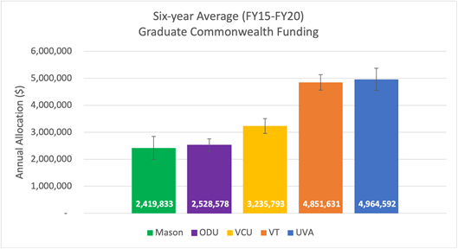

In order to obtain parity of per-graduate-student funding with other Virginia R1 institutions, we request an additional $5.3 million in graduate aid from the Commonwealth to support graduate student recruitment, retention, and degree completion through scholarships, fellowships and other financial aid grants. We are requesting this funding augmentation over two years, or $2.65M per year for FY23 and FY24.

Reinvent Graduate Education
In addition, with more than 10,800 students enrolled in graduate programs and many more having completed their master’s or doctoral degrees, Mason has become a significant producer of advanced degrees and contributor to a specialized workforce in Virginia and beyond. However, despite our ongoing successes, Mason has been impacted by rapid and significant growth, which has led to significant challenges that could compromise the continued success of our initiatives that advance learning, support research, and promote scholarly study and professional development opportunities. Such challenges ultimately can affect graduate students’ achievement of their personal and career goals.

In order to enhance graduate education effectiveness and efficiency, cross-disciplinary and experiential learning, and career and professional development, a graduate education task force was formed recently. The Task Force was charged with examining the current state of graduate education at Mason and identifying strategies and inventive approaches that will facilitate consistent and equitable expectations, enhance opportunities for interdisciplinarity both within and across academic units and strengthen both operations and structures that support graduate students.

The main goals include:

- Identify best practices and review Mason’s current graduate education and opportunities and associated challenges.
- Identify and consider R1 institutions’ models and identified practices, review and consider strategic solutions to help to overcome challenges.
- Suggest operational and structural enhancements that will facilitate the implementation of the opportunistic solutions.
- Provide recommendations with respect to structures that support graduate education and graduate students to best align with the University’s mission, vision, overall structure, strategic objectives, and funding allocations, including the prospective formation of a Graduate School at Mason.

To attain these initiatives, Mason will need an additional $1.7 million in annual funding to support graduate student interdisciplinary and experiential learning as well as advanced career and professional development. We request that the Commonwealth provide a 50 percent cost-share over the next two years, or $850,000 per year so that we may achieve these objectives.

The chart below shows that, although Mason consistently confers a higher number of graduate degrees in comparison to our Commonwealth peer institutions, we receive less Commonwealth graduate aid annually.

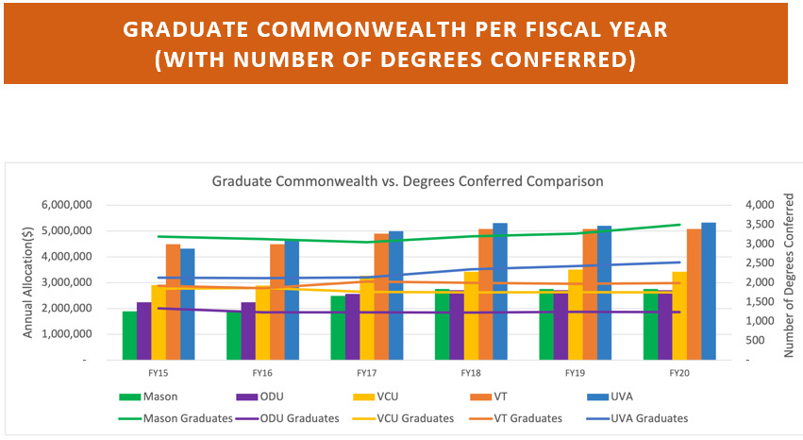

Strategy 3. – Addressing Faculty & Staff Inequities: Attracting & Retaining Talent
Market/Equity Issues
Mason’s sustained success as a nationally ranked R1 university is directly linked to the talented, dedicated faculty and staff who are committed to and strive for outstanding achievement in education, research, and public service. Their outstanding contributions have brought Mason regional, national and international recognition. However, compensation is a key element in attracting and retaining the brightest and most talented individuals, and Mason’s salary appropriation continues to lag behind the majority of public research institutions in the commonwealth, despite the fact that we operate in a location with the highest cost of living in the Commonwealth. When comparing Mason’s appropriated salary to its SCHEV peers, Mason is ranked 19th out of 26 for overall average faculty salary. Mason needs approximately $20 million to reach the 60th percentile of its SCHEV peers for teaching and research salaries. Staff compensation also has been impacted and continues to be a barrier to our recruitment and retention efforts. Competitive salary increases based on an annual merit and recognition process for contributions and efforts is crucial in keeping pace with market competition and reducing turnover for both faculty and classified staff.
While Mason’s external recognition for quality of work life speaks to its productive and rewarding work environment, compensation packages remain key to attracting and retaining high-quality faculty and staff. For Mason, compensation includes salary, benefits, startup packages and cost-of-living adjustments.
In the short term, Mason must manage both increasing competition for faculty and staff talent and significant attrition through faculty retirements. For top-notch talent, Mason competes with universities regionally (e.g., George Washington University, Georgetown, American and University of Maryland) and nationally (e.g., Northeastern, Temple, UCLA), as well as with private companies and government agencies in Northern Virginia. Given our regional location, it is a competitive environment unique among Virginia universities.

Faculty Inequity
In the coming decade, Mason anticipates up to a 25 percent turnover in its faculty ranks due to retirements. This will have a profound impact on our ability to maintain our current quality and mix of faculty. First, hiring new faculty talent is subject to intense regional and national competition, and Mason’s current salary levels are significantly below market causing major challenges in recruitment. Second, most faculty retirees will be full or associate professors. In order to maintain an appropriate mix of faculty ranks, we will need to replace many of these open positions at comparable levels.
Over the past year, Mason has developed a compensation philosophy and conducted a faculty equity study in partnership with an external consulting group to assess compensation practices. A project focused on faculty compensation has been initiated and, in partnership with each academic unit, Mason will develop a discipline-based salary structure that will have market competitive ranges. The new structure will provide the tools needed to conduct comprehensive faculty compensation analyses and will provide a framework to address issues such as compression, inversion, internal and external alignment. We are also working on a staff market/equity analysis to develop a framework for addressing salary compression and inequity.
In FY22, Mason will allocate the state-authorized salary increase of 5 percent on average for teaching and research faculty, administrative and professional faculty, and classified staff and evaluate the effect of the raise relative to our SCHEV peer group and R1 institutions. Compensation studies will be conducted for faculty and staff to look at internal and external alignment, including market analysis. We project that we will need to invest an additional $20 million to begin to address the market gap, compression and equity issues for faculty. Our preliminary analysis of the staff market/equity adjustment needed is $26 million. This is a significant investment and will require a multi-year plan. We request a 50 percent cost-share from the State to address the $6.6 million faculty market adjustment needed over FY23-FY25, or $3.3 million per year with the balance coming from our non-general fund resources.

Staff Inequity
Mason has historically operated and continues to operate with a significantly lower level of staff support relative either to other R1 peers or other public institutions in the Commonwealth. The chart below shows a time history of Mason’s staff to faculty ratio compared to the levels reported by the R1 institutions in the United States. The R1 institutions are represented by the quartiles and the median. Note that Mason is in the lower quartile (for reference, approximately at the 14th percentile among the R1 institutions).
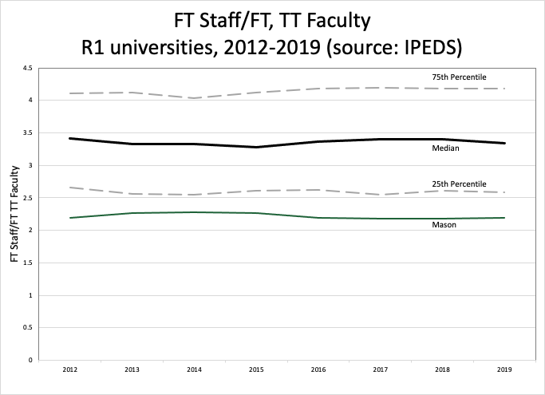
The pattern of relatively lower levels of staff support is also manifested when compared to other Virginia public institutions. The charts below depict the relative size of Mason’s staff compared to other Virginia public institutions. On the left, one can see that Mason’s staff is medium sized among the Commonwealth’s institutions. On the right, the chart shows full time, non-instructional staff per full time equivalent student for institutions within the Commonwealth. The combination of a modest staff size and Mason’s large student population means that Mason clearly operates with a much smaller staff as a function of student population. The effect is not strictly a function of scale, as institutions with both much larger and much smaller populations than Mason can be found well to the left of Mason’s position on the chart below right.
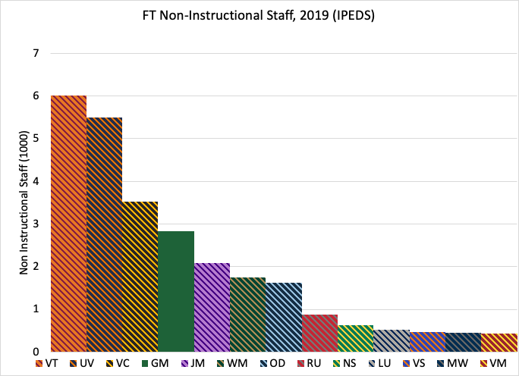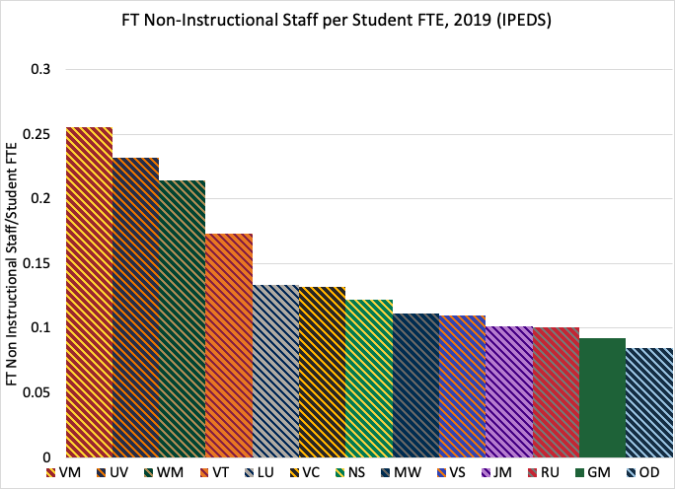
There are many initiatives underway to better serve faculty and students at Mason. Bringing service levels and workload to at least the median among Virginia universities will require a substantial increase in the number of new staff. The median staff-student FTE ratio on the chart above is approximately 0.122, as compared to Mason’s actual level of about 0.093 - a difference of 0.029. Applying that factor to Mason’s full-time equivalent student population suggests an increase of about 890 staff. At Mason’s average staff salary, this suggests a need of roughly $62M. Clearly this is a larger increase than can practically be accommodated in a single or even a handful of years. Accordingly, a more modest increase has been suggested as a step toward reducing this gap.
Although the staff equity analysis is still being refined, our preliminary analysis of the staff market/equity adjustment needed is $26 million. We want to begin to make headway on addressing what we know are persistent understaffing and salary market issues. We plan to invest $2 million per year to address both staff market inequities over FY23-FY25. We ask the Commonwealth to partner with us in this effort and provide 50 percent of the $2 million investment needed ($1 million per year) over the next three years. We will fund the balance with non-general fund resources.
We are requesting a total of $4.33 M per year from the State, or 50% of the total $8.66M needed, to help us address persistent faculty and staff inequities.
Our new Six-Year Plan reflects an annual salary increase of 3 percent for teaching and research faculty, administrative and professional faculty, and classified staff.

Workforce Planning: Hiring Required to Meet Enrollment Needs & Strategic Priorities
Enrollment increases will impact every Mason college and school, although some will likely be affected more than others, and the institution is uniquely poised to find talent at all socioeconomic levels in the Commonwealth, especially those classified as high or moderate need, delivering new productivity to stressed labor markets. For example, impressive enrollment increases in the engineering, science, business, and health fields will continue to drive a growing number of STEM-H offerings. With the support of the commonwealth, the university can expand its educational opportunities, producing a three-fold economic return on investment: 1) preparing a world-class workforce, especially in STEM-H fields; 2) enhancing the commonwealth’s competitiveness in research and development, which is essential to success in the knowledge economy; and 3) translating the advances generated by university researchers into products and services that contribute to improved Virginia’s health, wealth, and prosperity.
Mason projects enrollment growth of 1,200 students each year for the next ten years. This strategic growth will focus on providing access to programs in demand by both students and employers, many STEAM focused. Mindful of the need to ensure a vibrant and supportive environment that creates opportunities for all parties to thrive, this enrollment growth demands coincident investments in instruction. Given our dual mission of access and research, maintaining an appropriate student/faculty ratio is critical. To that end, we anticipate the need to incorporate 400 new faculty lines over the next decade, or about 40 additional tenure-track faculty annually.
These 40 additional tenure-track faculties will provide a high-quality education experience to a growing student body and boost the university’s research and innovation productivity. These new hires will address the Virginia Plan in multiple ways, especially the impactful effect of driving change through investment and innovation. Of these 40, about 10 new faculty hires annually will be for TTIP hires, funded with our ongoing TTIP State support, within our new College of Engineering & Computing, encompassing the Volgenau School of Engineering and new School of Computing, the College of Science, and other STEM departments across the university, so that we can significantly increase the numbers of career-ready STEM undergraduates and graduates.
Each faculty line is estimated at $150,000 for salaries and fringe benefits. These estimates are in alignment with recent faculty recruitments. We are asking the State to support half the $4.5M annual cost of 30 new faculty hires each year, or $2.25M annually, to meet our growing enrollment needs over the next six years.
We also need to address our critical staffing shortage and the need to make strategic hires to support enrollment and our student success initiatives. We will need to hire in excess of 20 new administrative and classified staff each year, with an average blended salary and fringe benefit cost of approximately $100,000 for each new staff line, or $2M annually.
In total, we are asking the State to partner with Mason and invest half the total annual cost of $6.5M (new faculty hires and new staff hires), or $3.25M each year to achieve these objectives.

Strategy 4 – Develop Infrastructure, Practices & Policies to Support Anti-Racism & Inclusive Excellence Initiatives
Mason’s Anti-Racism, Inclusive Excellence (ARIE) Initiative was one of three top priorities that George Mason University President Gregory Washington announced when he began his tenure as Mason’s eighth president on July 1, 2020. His vision for Mason is to become a national exemplar for antiracism and inclusive excellence. Soon after his arrival at our university, he appointed the ARIE Taskforce along with six associated committees and charged them with working to dismantle policies, practices, and traditions of racial bias on campus, while also positioning Mason as a national beacon for the advancement of anti-racism, reconciliation, and healing. He announced a $5 million investment over a three-year period for the ARIE work.

After several months of work, the taskforce and committees submitted 62 recommendations to advance anti-racism and inclusive excellence at Mason. They prioritized the top 15 as a beginning point for implementation. These priorities were presented to and received feedback and broad support from the Board of Visitors and the entire Mason community. Please refer to Section L of the Six-Year Plan for detailed recommendations.

The 15 strategies are now in the implementation phase, with 15 senior-level leaders charged with turning the recommendations into action. Implementation of these 15 prioritized recommendations will require an investment of $9.3 million from FY22 through FY24. Mason has identified strategic reserves to fund the first year’s projected $3.1M of investment needed. We ask the Commonwealth to partner with Mason in funding the remaining balance of $3.1M per year for FY23 and FY24, or $1.55 million per year.

We still need to make progress on many of the other 47 recommendations over the next six years. As we evaluate our progress and the impact of the implementation of the first 15 recommendations, we will refine our future investment needs as we seek to transform Mason to become a national exemplar of anti-racism, reconciliation and healing.

Strategy 5. Elevate Research
Elevate Research to Generate New Knowledge for Global Grand Challenges: Mason met an institutional goal and entered the upper echelon of U.S. research universities as a Carnegie Research 1 (R1) University in 2016, which was reaffirmed in 2018. This remarkable achievement for an institution less than 50 years old was made possible by the world-class contributions of our faculty, staff, and students in fields such as economics, history, psychology, criminology, engineering, and computing, among others. Mason researchers and scholars continue to produce knowledge and insights that address pressing world problems and reveal promising new futures. Moreover, we integrate the knowledge we create into state-of-the-art education programs to prepare a creative and engaged workforce that will use this knowledge to create economic opportunities and a better quality of life for all. By strengthening our capacity to conduct world-class research and scholarship, Mason serves as an engine for innovation and growth in our region, the commonwealth, and the nation.
We continue to make strategic investments that ensure our long-term continued success—recruiting and retaining eminent tenure-line faculty at all levels of seniority and generating more high-quality scholarly outputs and outcomes reported by our faculty in leading publications, journals, international conferences, and other venues.
We also continue to make investments that support our faculty’s efforts to increase sponsored support for our programs, with targeted efforts to stimulate revenue growth from federal and industry sources. In the last two years, we have reported significant growth in R&D expenditures, increasing from $184 million in AY 2019 to $221 million in AY 2020. Given this impressive trajectory of funded research expenditures and recent awards received, we project that we will exceed the goal described in our Strategic Plan of reporting $225 million R&D expenditures before AY 2024.
For our research and scholarship programs to grow and prosper, we must provide our faculty, staff, and student researchers with access to world-class research infrastructure, including state-of-the-art research labs, facilities, research and computing capacity, equipment and instruments, and an empowering research administration enterprise that minimizes administrative burdens while promoting the ethical and responsible conduct of research and scholarship. Making sustained investments in research infrastructure has been very challenging at Mason largely because most external sponsors require matching funds, and the commonwealth’s HEETF allocation to Mason is significantly lower than allocations at other Virginia R1 institutions. We cannot stress enough how important it is that the administration make an adjustment in Mason’s HEETF allocation for AY 2022 and beyond. We request an additional $5 million per year to support investments in research equipment.
To further strengthen our performance, we are engaged in several comprehensive campus planning exercises at our SciTech and Arlington Campuses that align and elevate our multidisciplinary research and education programs and initiatives. We are making good progress, with plans to concentrate and expand 1) our wet lab-intensive STEM-H research and education programs at graduate levels on our SciTech Campus, and 2) our professional graduate education and research programs in computing, law, business, and public policy on our Arlington Campus with new programs added to strengthen the tech innovation ecosystem.
We continue to seek strategic partnerships with other entities with similar interests. For example, we are working closely with a developer partner and Prince William County on the development of a mixed-use Innovation Town Center adjacent to our SciTech Campus. This development promises to provide much-needed residential options for our faculty, staff, and students immediately adjacent to campus, as well as critical university life amenities. In Arlington, we are working closely with a number of partners—including Arlington Economic Development, Amazon, our academic partners, and others—to develop an innovation district at Virginia Square that will drive economic development and long-term support for a tech innovation ecosystem that promotes economic and social inclusion.
Finally, to support our increasing research capacity, we are actively engaged in the redesign of Mason’s support for graduate education, with the goal of attracting and supporting a larger and more vibrant graduate student community with a higher proportion of full-time PhD students.
In addition to elevating the quantity and quality of our research, scholarship, and creative activities, Mason is strengthening the impact of its research outcomes. In the last six years, we have created three new university-wide institutes to support multidisciplinary research, innovation, and economic development initiatives in support of addressing “global grand challenges”. These institutes provide support for our faculty, staff and student researchers and scholars, facilitate the engagement and support of external partners and individuals with similar interests, and strengthen the impact of the outcomes that we generate. They support our increasing engagement with stakeholders in the communities we serve—local to global—to support the mutually beneficial exchange of knowledge and resources in the context of partnership and reciprocity.
The Institute for Biohealth Innovation (IBI), formed in December 2015, brings together 250+ faculty from across 10 colleges/schools with a mission to address the global grand challenge of advancing human health and wellness at multiple scales. IBI seeds and supports the development of new multidisciplinary research and education programs, attracting additional external funding to enable their implementation and success. IBI supports partnerships with external private- and public-sector organizations, such as the National Institutes for Health, Inova Health System, and the U.S. Department of Justice, providing a one-stop shop for partner organizations who seek access to Mason’s world-class faculty, staff, students, and postdoctoral trainees with relevant expertise. IBI actively supports the translation of research outcomes into impact, including nurturing an emergent biohealth innovation ecosystem that includes support for new venture formation in partnership with other external stakeholders like VA BIO and the Virginia Catalyst. IBI faculty are currently leading partners with VA BIO in a Commonwealth-wide strategy to create and support growth of new life sciences companies in partnership with Virginia’s research universities, health systems, and private-sector entities. ibi.gmu.edu
The Institute for a Sustainable Earth (ISE) was launched in February 2019 to advance research and education programs that contribute to the development and support of communities here and around the world that are just, safe, economically secure, and environmentally sustainable. Mobilized by the challenges of our 21st century world encompassed in the UN Sustainable Development Goals, or Global Goals, ISE conducts multi- and trans-disciplinary research that impacts society on various topics including, but not limited to, climate change, educational access, peace, justice, and strong institutions, biological, geological and atmospheric research to understand our world and much more. ISE brings together some 500+ faculty from Mason’s 10 colleges/schools. ISE seeds and supports the development of new multidisciplinary research and education programs and projects, attracting additional external funding to enable their implementation and growth. ISE promotes and supports partnerships with external private- and public-sector organizations, such as the United Nations, the U.S. Sustainable Development Solutions Network, and the National Oceanic and Atmospheric Administration, and is one of only three U.S. Global Future Earth sites focused on accelerating transformations to global sustainability through research and innovation. ISE actively supports the translational research that will inform the development of new methodologies, technologies, and approaches to make our socio-political, built- and eco-systems more resilient to disruptive, undesirable change and better positioned to thrive in a rapidly changing world. We are requesting $1 million in annual support for ISE, which will support community-engaged projects that enhance the resilience of Virginia communities in the face of the increasing occurrence of extreme weather and socioeconomic disruptions. ise.gmu.edu
The Institute for Digital InnovAtion (IDIA) was launched in June 2020 with a mission to create and harness the power of advanced computing techniques, technologies, and systems to democratize opportunity and advance economic and cultural prosperity, major global grand challenges. IDIA brings together some 300+ faculty from Mason’s 10 colleges/schools and seeds and supports the development of new multidisciplinary research and education programs, attracting additional external funding to enable their implementation and growth. IDIA promotes partnerships with external private- and public-sector organizations, such as Mitre, Amazon Web Services, Apple, Northrop Grumman, the Department of Defense, and the Department of Homeland Security, providing a one-stop shop for partner organizations like who seek access to Mason’s world-class faculty, staff, students, and postdoctoral trainees. An integral component in our contributions to the commonwealth’s Tech Talent initiative, IDIA will have a significant presence in the new innovation district under development in Arlington’s Virginia Square neighborhood. Led by Mason in partnership with numerous public- and private-sector organizations, including Arlington Economic Development, Arlington Public Schools, Northern Virginia Community College, Marymount University, Booz Allen Hamilton, Amazon Web Services, and many others, the Innovation@Virginia Square initiative will engage and empower a diverse community of Arlington entrepreneurs to strengthen the commonwealth’s innovation economy. We are requesting support of $1.5 million annually to increase the number of successful tech start-ups created and residing in Virginia to grow our innovation economy.
Implemented as inclusive initiatives that leverage the full complement of our university community’s expertise—including the arts, humanities, and social and behavioral sciences as well as the natural, computing, and engineering sciences—these three Mason institutes promise significant long-term impact from local to global.

Strategy 6 – Enrollment: Funding Disparity Support
In addition to supporting new enrollment growth, Mason must address its historic funding disparity from its past enrollment growth. In 2019, we determined that Mason would need an additional $49.2 million in base augmentation in Commonwealth support to be on par with the average Commonwealth support for in-state students with our doctoral peers. The Commonwealth has provided a very generous initial investment of $10 million in FY21 and $21 million in FY22 for enrollment support, with an additional $9M for base operations. This $31 million investment will enable us to begin to make critical investments in our academic and research mission. With the $31 million in incremental base support, the state support gap between Mason and its doctoral peers is now $18.2 million. We recognize that this level of support will require a multi-year commitment; therefore, we are requesting that the Commonwealth invest $9.1M million per year over the next two years (FY23-FY24) to meet the instructional and academic support needs of our students.

The funding chart below shows Mason’s funding in comparison to the other five doctoral institutions.

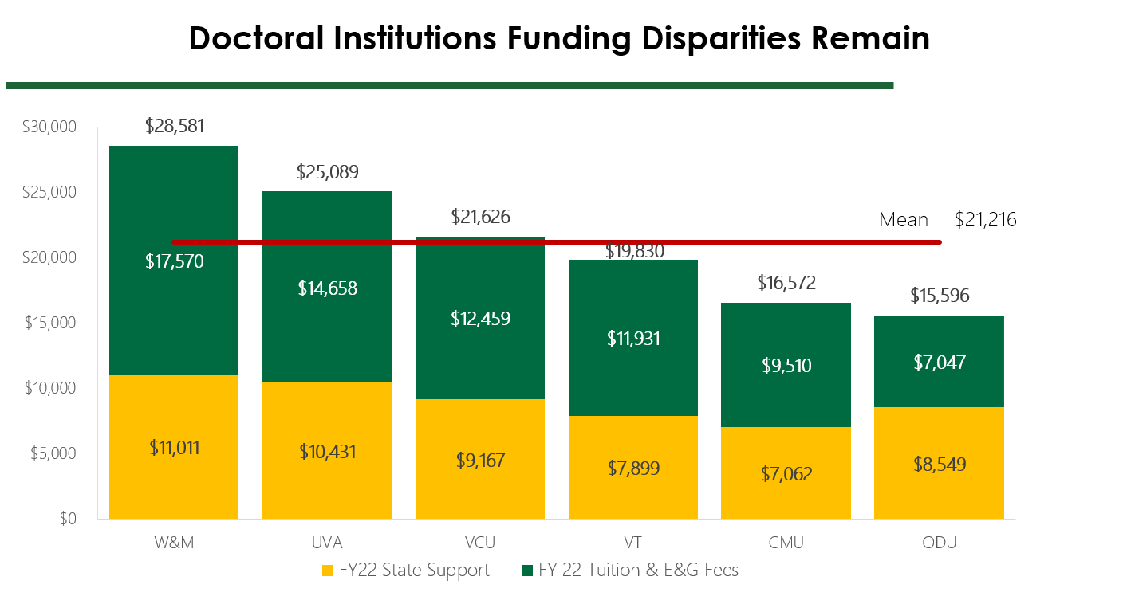

Base Budget Adequacy

The State’s funding guidelines for assessing base budget adequacy for VA institutions is an important metric to have in place to evaluate the total resources needed by each institution to achieve its mission. We have carefully reviewed the State’s Base Budget Adequacy methodology and calculations. Our analysis shows that the current model disadvantages those institutions such as Mason with large student enrollments and a significant percentage of high need students. Moreover, several of the input variables used to calculate resource needs are outdated. We know that the State is revisiting the adequacy model in the next two years, and we look forward to providing input on the new model assumptions, methodology and calculation of resource needs.

While we recognize that this review of the adequacy model is coming, the existing model provides a useful comparison relating to this $18.2 million gap, particularly given that the model in its current instantiation is sometimes used as an argument against the existence of this very gap as the current calculation shows Mason funded at a level above the base adequacy level. The adequacy model relies on a number of inputs and assumptions, including sets of cost factors developed from regression analyses. These factors require substantial effort to update using statistical methods and data drawn from authoritative databases, such as the Integrated Postsecondary Education Data System (IPEDS). Such analyses may not be repeated regularly as a practical matter. However, some variables used as input to the model can be readily updated to reflect current conditions. Three specific examples include average faculty salary (where $92,168 is used, as compared to actual of $106,580), benefits rate (20.56% used, as compared to actual of 32%), and a cost-of-living adjustment (COLA) of 8.57% for northern Virginia. The salary number is based on the 2003 average, inflated via subsequent appropriations – which misses changes in the market. The benefits number purports to describe actual benefits out of direct expenses but is misapplied solely to salary expenses. The COLA factor reportedly derived from a 1988 salary differential for the state police. All three values can be easily updated in the existing model. Actuals are readily available for the salary and benefits values. For the COLA, we recognize that estimates vary dramatically and range up to as high as 50-60% higher. Entering a modest value for the COLA of 17% or roughly twice the 1988 era number, along with the actual salary and benefits values, and leaving all other factors constant, Mason’s base adequacy level drops to approximately 97%. This 3% gap compared to the base adequacy level, when applied to a total need of approximately $600 million, coincidentally leads to approximately $18 million and provides confirmation of this level of funding disparity.

Strategy 7 – Expand Economic Development
Mason Enterprise work in the important domain of economic development consists of 1) State and federal programs that support small business and entrepreneurship in the Commonwealth, 2) the Mason Office of Technology Transfer, 3) the entrepreneurship-focused experiential programming inside and outside Mason, 4) the MIX maker space on the Fairfax campus, and 5) four economic and business incubators across Northern Virginia (Mason Enterprise Centers).
Last year the Mason Enterprise team, through these interconnected programs, provided 27,000 hours of 1:1 counseling to more than 10,000 small businesses, covering every county in the commonwealth and delivered 859 small business and entrepreneurial training programs to 18,000 Virginia attendees. More than half of the businesses served were owned/led by women and minorities. During the period of COVID, the team’s typical daily work increased 120% and they were responsible for helping to deliver $56M in CARES act funding to small businesses. Mason’s total impact on small businesses and entrepreneurs last year was $2B in the Commonwealth. This is possible because of the interaction among Mason Enterprise services and across its relationships with local economic development organizations, incubators, non-profits, service providers, and industry partners.
Mason supports tech start-ups across Virginia, regardless of location, working in partnership with the universities and local economic development partners, though currently there is only one program Commonwealth-wide that supports this variety of tech entrepreneurs and it is led by Mason. Through this program in FY2020, Mason supported 243 early-stage tech businesses with a direct economic impact (investments, new product revenues, etc.) of $11 million. 42% were woman-owned and 38% were minority-owned tech businesses. Mason received $300,000 to run the program (a 36X ROI). In FY2021, the number of companies served will be even larger as the program has gained momentum over its first three years.
Mason Enterprise’s strategic plan is to build the foundation of a strong, inclusive entrepreneurial ecosystem, focusing on three core pillars. All of Mason’s activities are designed to increase the diversity of the tech economy in Virginia:

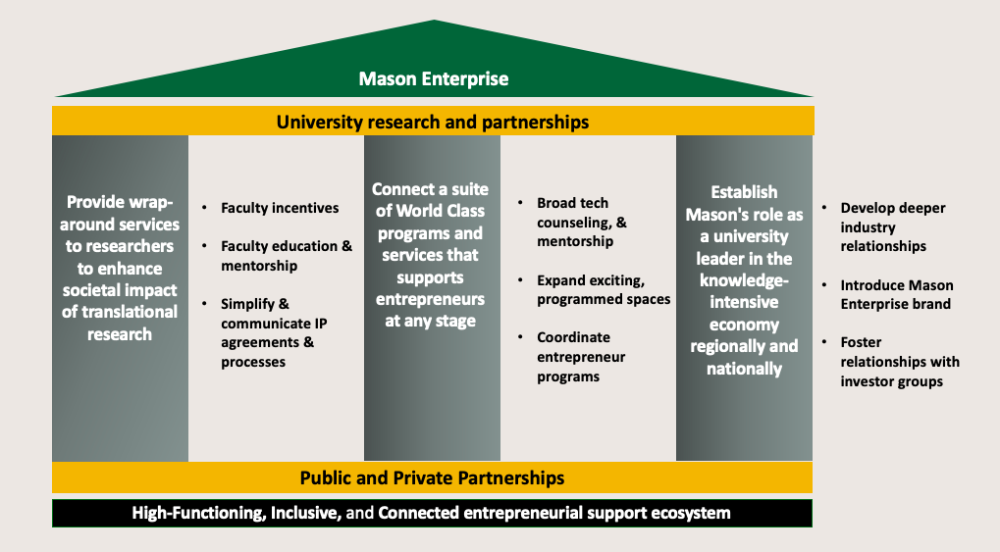
Approximately 80% of the funding that Mason Enterprise receives from various public entities goes to non-tech entrepreneurship and small business support. The strategic plan for these initiatives seeks to leverage the existing support systems and build on the counseling, communications, and tracking systems in place to grow the technology services that support Virginia’s plan to increase its competitiveness, increase economic growth, and create more tech-related companies and jobs.
From our experience, we know that like every good program, the right person at the helm – typically someone with industry experience and an understanding of university operations to bridge the gap – will want to see at least three years of funding to accept a position. Similarly, results typically appear in the second year of a tech program.
Also, from experience, tech commercialization and entrepreneurship programs have a higher-than typical return for public dollars (usually 10:1 or greater).

Budget
Pillar | Program activity | Annual Cost | 6-year cost, 50%
Provide wrap-around services to researchers, enhance societal impact of translational research  Annual Cost: $1,800,000  Ask: $5,400,000 | Faculty education, mentorship, and product launch  Coulter program for translational research  Translational Research education  Annual event celebrating innovators across Virginia | $400,000  $1,100,000  $250,000  $50,000 | $1,200,000  $3,300,000  $750,000  $150,000
Connect World-Class programs and services  Annual Cost: $2,810,000  Ask: $8,430,000 | Tech Mentorship Team  Tech Start-up Internship Program  Interdisciplinary tech commercialization programs  First Customer Program | $1,100,000  $1,150,000  $260,000  $300,000 | $3,300,000  $3,450,000  $780,000  $900,000
Establish role as leader in knowledge economy  Annual Cost: $690,000  Ask: $2,070,000 | Establish a Corporate Engagement Center  Investor event to draw capital into the Commonwealth  Convene ecosystem to remove barriers to tech commercialization | $350,000  $300,000  $40,000 | $1,050,000  $900,000  $120,000
 |  | $5,300,000 | $15,900,000

- Provide wrap-around services to researchers to enhance societal impact of translational research.
In lay terms, we are focused on ensuring federal research benefits Virginia’s citizens and its economy. Mason’s recent 110% growth in research, combined with 53% growth in invention disclosures - leading up to this year’s record number – means more opportunity to build its lab-to-market activity. In 2019 NIST commissioned a study of the top 59 public research universities across the country to determine best practices in lab-to-market activities. Mason intends to adopt these identified practices to increase the number of start-up companies and licenses to industry. In the next couple of years, those activities are:

Faculty Incentives
- Review innovation & entrepreneurship as an element of promotion & tenure. Mason is currently following national trends, participating in a national workgroup, and evaluating how to proceed with this culture-shifting policy.
- An annual innovation award event is in the planning stages for Q1 of 2022, to recognize faculty who are serial innovators
- In Q3 2022 Mason will explore building a seed fund to fill gaps in federal, private, and state funding internally to facilitate the growth of more tech commercialization and encourage faculty through resources.
- Mason would like to request a signed letter from the governor, congratulating faculty whose inventions have successfully made it to the market. This is one step toward fostering a culture of translational research and commercialization with virtually no cost.

Faculty Education & Mentorship
- A series of faculty and masters/doctoral student technology commercialization workshops will be launched in Q4 of 2021. These will augment, but not overlap publicly available information to encourage more SBIR/STTR submissions, increase in invention disclosures, and generate interest in commercialization.
- In Q1 2022 Mason intends to launch a Coulter model program that specifically addresses commercializing technologies in digital innovation. This successful model has been run for 15 years across the country and derives its success from addressing the gap in prototype development, involving an oversight committee of industry and investment professionals, and dedicated staff to moving technologies forward. Once this has been launched successfully, Mason will expand the program for other universities to access.
- Mason is working with business and engineering faculty to create a translational research curriculum using actual promising research and start-ups as case studies. The purpose is threefold: move technologies forward into the market, provide needed support to faculty and start-ups, and educate students.

Simplify & Communicate Intellectual Property Agreements and Processes
- The standard Mason IP agreement is being reviewed by faculty and staff, with a revised document to be finalized by the end of Q4 of 2021. The focus on clearly stated terms that will facilitate ease of use and understanding.
- The communication of the IP policy will also be promoted to industry partners to encourage growth of sponsored research. Mason is currently adding staff to foster more industry collaborations.

Connect a World-Class Suite of Programs and Services that Support Entrepreneurs
Broad Tech Counseling and Advisory Services
- Twenty states in the U.S. have tech-focused Business Advisory Teams, but Virginia does not. By Q3 of 2021 Mason plans to launch a tech-focused team to support technology companies in the commonwealth, pending Go Virginia grant support. With this team, every tech start-up in Virginia will have access to no-cost business advice, introductions to customers, team members, capital, and fundraising support by professionals who have built tech companies in the past.
We envision 14-18 months of funding will launch this program. A long-term solution is necessary at the state level, as with other states. Expected ROI, based on other states, is 70:1.
Expand Exciting, Programmed Spaces
- Mason will be opening a fifth incubator (Mason Enterprise Center) to support the new activities growing in Arlington. Discussions are ongoing with Arlington County to help support the new incubator and an increased mentorship presence.
- The maker space in Mason’s newly opened Horizon Hall is a beautiful new location that must be programmed to benefit budding student entrepreneurs and faculty with inter-disciplinary equipment training and entrepreneurship workshops. Anticipated launch is Fall 2021. The programs offered in the maker space are available broadly and some will be broadcast.

Coordinate Entrepreneur Programs Across Mason
- Mason has already partnered with other universities and non-profits on cyber internship programs as well as associated training and education. Last semester 147 Mason students applied for 16 open internship positions at cyber security start-ups. Of those who were placed, 70% were women and minorities and more than half received job offers. Expansion of this program into other technology verticals that support the Commonwealth’s strategic plan will place more students in tech start-ups.
- Mason is connecting its many external and internal training and education workshops across the Commonwealth so that innovators and entrepreneurs of any age, regardless of affiliation, can participate.
- Mason intends to replicate a successful “First Customer Program” where masters students – supervised and reviewed by a marketing expert - leverage university research resources to produce Market Strategic Opportunity documents (MSOs) for tech start-ups, scope a specific marketing project, and facilitate a project designed to launch a new product into the market. Start-ups typically can’t afford the library resources available, creating a mutually beneficial program. This program has a high ROI and educates students on the process of new technology product launch.

- Establish Mason’s role as a university leader in the knowledge-intensive economy regionally and nationally through awareness and access to resources.

Develop Deeper Industry Relationships

- By the end of Q4 2021 Mason plans to launch a corporate engagement center to more systematically bring university faculty to solve problems and deepen interactions with the private sector and faculty innovations.

Introduce Mason Enterprise Brand
  - One of the items required under the TTIP funds agreement is the completion of an innovation district plan that identifies how Mason can best impact tech development and economy around Arlington. It also explores how to pull that work through an innovation corridor connecting with all three Mason campuses. This is targeted for completion Q4 2021 and is on schedule.

Develop Relationships with Investor Groups
  - Mason is planning an economic development-focused investor event in Q4 2021. Investors from around the country, together with luminaries in the investment sector will be present for an event open to any university and start-up in the Commonwealth to participate. We are planning for this to be an annual event.

Funding Request

We are requesting the State support half the $5.3 million annual cost of these initiatives for the next six years, for a cumulative investment of $15.9M of the $31.8M total resources needed. As long as these programs are implemented and continue, the outcomes and return on investment and value will grow over time. This will provide Mason with the necessary resources to help diversify the economy, grow the tech sector, educate students, shift faculty culture, and bring more research to market.

Strategy 8 –Digital Innovation: Efficient Instructional & Operating Models

Rapid advances in technology are fostering innovation in higher Education, both in academic service delivery and administrative operations.
Technical innovation expands access to affordable education and improves the quality of that education in on-line modalities. Pre-pandemic, faculty and staff, embracing innovative, technology-driven service models were already blurring the lines between a traditional on-ground education and online instruction; many traditional institutions were adopting online offerings as a part of their portfolios, given the potential reach and economic efficiencies. Leveraging these advances is especially important at Mason, where our undergraduate student demographic is typically first-generation and often economically disadvantaged, with students balancing the desire to achieve academic success with the reality of economic and familial responsibilities. Adopting and expanding our technological footprint allows us to expand the scope/quality of our academic programs, improve access to those programs and potentially make them more affordable.
Mason has long had plans to develop online programming to meet the various needs of the diverse populations we serve, and the pandemic has been a catalyst for both online and hybrid initiatives. By capitalizing on the extraordinary work of our faculty during the pandemic, Mason has made profound changes through course re-design, use of technology and training that build on the on our strengths in online, hybrid and ground-based instruction. The rapid transition from traditional modalities during the pandemic has informed theory with practice and provided us with the opportunity to understand what works, what doesn’t work and what we need to do to serve the future needs of our students and faculty. Representative examples of investments that we are making from an academic perspective to take advantage of this momentum include designing new hybrid and on-line courses, investing in training faculty to program and manage hybrid and on-line coursework and retrofitting our classrooms and technology-enabled conference rooms to support hybrid service modalities. We are also continuing to invest in our academic services portfolio, including upgrades to our Salesform platform (CRM), investments in Coaching and Advising technologies and harmonizing our student support models to better serve students, regardless of which modality they choose to attend Mason. Lastly, we are also assessing new markets that can be targeted by leveraging these technology investments, such are training and reskilling displaced workers for new career opportunities, focusing on emerging areas of workforce demand and expanding our non-credit bearing offerings, micro credentials and industry certifications.
Technology-driven advances are not limited to just academic service delivery. Recognizing that there is little administrative distinction between an employee or student on campus or in remote locations, Mason is also creating back-office administrative processes which meet our stakeholders “where they are” in order to simplify access to financial services, back- office administrative processes and to also improve fiscal operating efficiencies. Upgrading our ERP, including harmonizing the Chart of Accounts, developing a Revenue and Cost Allocation budget model and reorganizing and augmenting our Fiscal/HR technology service team are some examples of multi-year investments that Mason is making to build a solid foundation in order to standardize our service delivery, improve our efficiencies and prepare ourselves for this future.
As an R1 university, we are also focused on improving research administrative efficiencies and are deploying a Research Administration Suite in conjunction with these initiatives, such that many of the administrative processes, like proposal development, management, submission and grant acquisition / reporting can be automated. This will improve the velocity of grant submissions, standardize / improve conformance to our stakeholder obligations and allow our research community to focus on doing what they do best instead of focusing on manual administrative processes.
The pandemic has also amplified the need to for adaptable technology in support of hybrid/remote workforce management. By providing some flexibility to our workforce with respect to work environment, we are able to attract and retain high-quality staff in Northern Virginia – where there is significant competition for skilled resources. Establishing collaboration environments, upgrading our on-line employee service capabilities and migrating to accessible hosted service models during the pandemic allowed us to quickly pivot to on-line remote administrative operations and we continue to build on those accomplishments.
Finally, we are also investing in a central technology Project Management Office to better manage all of these investments, ensure conformity with best practices and ensure that the projects are appropriately prioritized, resourced, organized, funded and managed to achieve our expected outcomes.
Our progress in all these initiatives is directly correlated to the level of investment that we are able to make on an annual basis. We plan on funding these initiatives using a combination of reserves, operating funds and potential State contributions to achieve these objectives. Once these initiatives are implemented, Mason will be able to realize efficiencies with automation, better systems, and more effective instructional, operating and service models. We will be repositioned to innovate with a stronger return on investment. These initiatives, in the aggregate will require significant multi-year investment. We plan to initially launch these projects with an investment of one-time funds of $5M per year over the next five years. We are asking the State for a 50% cost-share in this investment since we will achieve longer term efficiencies that will ultimately increase revenue and save operating costs.

SECTION C. In-State Undergraduate Tuition and Fee Increase Plans: Provide information about the assumptions used to develop tuition and fee information the institution provided in the Excel workbook Part 1. The tuition and fee charges for in-state undergraduate students should reflect the institution’s estimate of reasonable and necessary charges to students based on the institution’s mission, market capacity and other factors.

RESPONSE:
Tuition Increase
Mason’s commitment to access and affordability to make education an engine of social mobility is a bedrock institutional value. Our tuition and fee increase plans reflect our mission to balance access with affordability with a modest tuition increase of 3% annually.
We carefully assess our tuition in relation to our peer institutions as well as student demand. Mason’s tuition has historically been the lowest among Virginia’s doctoral institutions. Our FY21 in-state undergraduate tuition was 18% below our closest doctoral peer tuition-wise, Virginia Tech.
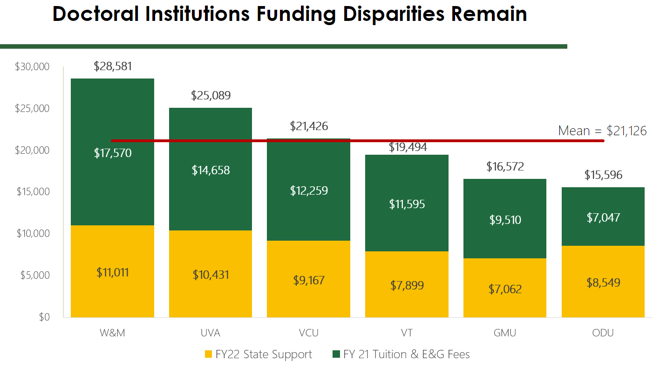
In recognition of the continuing budget pressures on our students given the pandemic and the resulting economic downturn, we did not increase undergraduate tuition in FY22. We anticipate that the economy will begin to recover over the next biennium. Therefore, assuming no additional State support, as the Six Year Plan instructs, we believe a 3% tuition increase ($285/FTE in-state UG student) will enable us to make progress on our strategic priorities for academic excellence, enhanced instruction in multiple modalities and student success focused on improved graduation and retention rates. Although we are proposing a tuition increase, we are also increasing institutional aid to offset the impact of this increase on the most vulnerable students.
We understand that as costs and enrollments continue to grow, Virginia public institutions will need to work in partnership with the Commonwealth on a more sustainable financial model.

Mandatory Student Fee Increase
We are planning for an annual 3% increase in our mandatory student fee. These incremental student fee revenues will be used to strengthen technology investments to support student-focused service delivery; to increase career readiness with expanded student employment opportunities; to provide increased direct student services focused on mental health and well-being and to increase student engagement with greater investments in student organization funding.
To improve transparency and facilitate better communication about the mandatory student fee, we will be working on redefining the current mandatory student fee categories to be more student-centered and to make it easier for students to understand how their student fees directly benefit their educational experience.

SECTION D: Tuition and Other Nongeneral Fund (NGF) Revenue: Provide information about factors that went into the calculations of projected revenue, including how stimulus funds may mitigate tuition increases.
RESPONSE:
Tuition and Other Nongeneral Fund Revenue is primarily driven from undergraduate and graduate online/other programs with premium fees to support specialized courses and instructional experiences. The rates are developed through a formalized fee committee that partners with the schools to ensure premium fees are competitive but maintain affordability for the students. Due to the pandemic, Mason as well as other institutions, has accelerated to an online platform significantly faster than planned. As such, Mason is now leveraging the ability to offer more online/hybrid programs to accommodate various students’ needs. Our other NGF revenues are driven by programs with premium fees to support specialized courses.

SECTION E: Other Budget Items: This section includes any other budget items for which the institution wishes to provide detail. Descriptions of each of these items should be one-half page or less
RESPONSE: Like most institutions during the pandemic, Mason catapulted much faster into the higher education virtual environment that originally planned. We have managed the ambiguity and uncertainty of this year by building a path to recovery focusing on institutional priorities that will allow us to leverage opportunities to offer flexibility for students, faculty and staff, reposition Mason for more efficient and effective operations and invest our resources in transformative financial and operational initiatives that will enable us to have more adaptable and flexible services and operations with new business and service models. Mason’s ability to adapt and innovate allowed us to find opportunities in this crisis—whether they were opportunities to support our students or protect our community, like testing and vaccines—or opportunities to position Mason for recovery and post-pandemic success.
By capitalizing on the leaps our faculty have made and the training they have been provided, we have found ways to build on the advancements we have made in virtual instruction and make that part of our future.
We are also capitalizing on some of the investments and innovations we made out of necessity that will change our pedagogy and work environment beyond Covid—such as virtual dance instruction or exploring new approaches for telework, enabled by investment in our technology infrastructure.
Mason has kept doing the work to continue our mission. We know the new higher education environment will be a hybrid campus with organic choices between in-person and online instruction. We are redefining classroom engagement beyond the benefits students get from sitting in a classroom; we are identifying high impact practices that make quality learning happen and making that investment.
We are also assessing new markets –retraining and reskilling displaced workers for new career opportunities and focusing on emerging areas of workforce demand and expanding our non-credit bearing offerings.
Below are several transformational initiatives that are currently underway, requiring multiple years of sustained investment. Once fully implemented, they will have a significant return on investment, value and transform the way we work:
  - Financial Operations:
- Revenue & Cost Allocation Model & Budget Redesign Project
- Chart of Accounts Redesign Project
- Workforce Planning: Recruitment & Retention; Competitive Compensation; Productivity & Remote Work and new ways of working
  - Instruction Innovation:
- Enhancing hybrid instruction with technology-enabled classrooms, labs and conference rooms
- Undergraduate Online Task Force is making recommendations to achieve the vison for a “portfolio of choice” for students to choose the modality of instruction for courses and access to associated student services.
- Advancing assessment practices to address academic integrity and increase engagement
  - Research Innovation & Infrastructure:
- Several critical investments are in process for Research Innovation and Infrastructure at Mason including implementing a comprehensive research administration suite, evaluating and enhancing research administration support, and investing seed funding to generate further external research funding.
  - Student Experience Redesign:
- For the last five years, Mason has been engaged in a series of efforts labeled as the Student Experience Redesign project which, among other things, recognizes that student attitudes have changed and so should the way Mason serves these students. Through this project, a number of new digital innovations have been prioritized to improve the way students access critical services/functions. Perhaps none more significant than the Identification of the Salesforce platform as a student lifecycle Constituent Relationship Management (CRM) system. Both Graduate and Undergraduate Admissions/Recruitment functions, New Student Orientation, and the one-stop Mason Student Services Center are presently supported using the system and a multi-year roadmap has been established. This tool will allow Mason to track all essential elements of a student’s experience, provide better access to virtual/remote services, and provide a platform upon which staff can identify critical interventions in the student’s journey towards graduation.

SECTION F: Enrollment Projections: Include in this section information about how your institution developed its enrollment projections, whether your institution is concerned about future enrollment trends, and, if so, what planning is underway to address this concern. How have enrollment plans been impacted by the pandemic? For example, does your institution plan on enrolling more online students?
RESPONSE:
Mason’s enrollment projections are informed by historical trends, recent investments in our recruitment infrastructure (including TTIP) and expected short term growth of high school grads in the Northern Virginia region. We project more in-state students to remain within the Commonwealth for their post-secondary plans and a multi-year increase in Mason’s graduate student enrollment because of the pandemic.
With much of Mason’s enrollment drawing from the Northern Virginia area, the projections of high school graduates from our region informs both our new freshmen and new transfer pipelines. The number of high school graduates within Northern Virginia is expected to peak and, unlike many states/regions, is not projected to dip below 2020 levels through 2040.
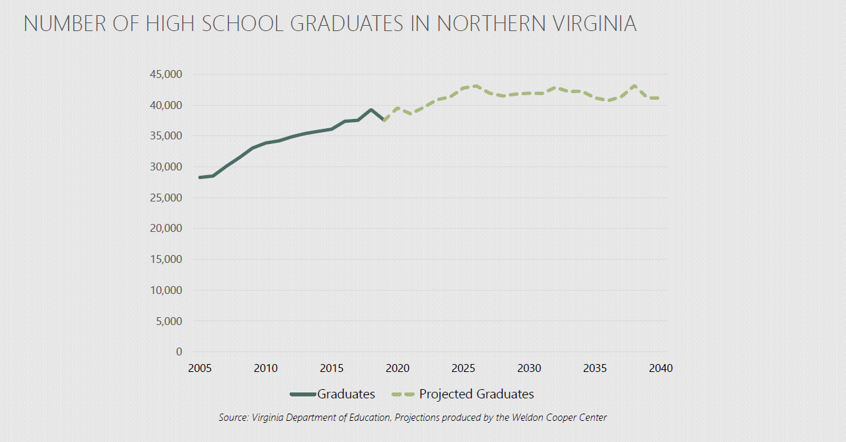Additionally, the top feeder states to Mason are expecting increases in the number of high school graduates. Using 2019 as a baseline, increases are predicted through 2025 before these feeder states shrink in size between 2025 and 2030.
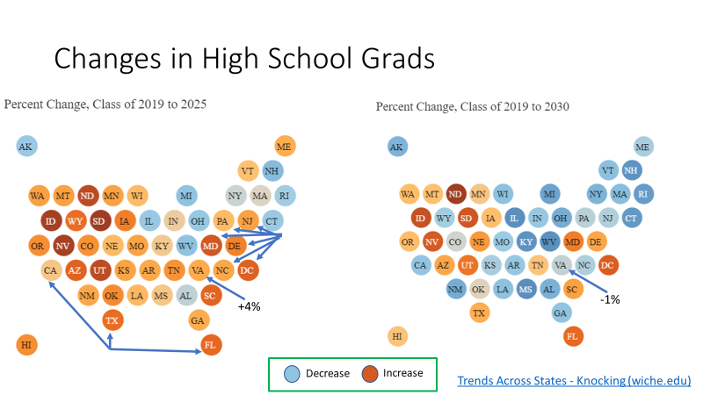

SECTION G: Programs and Instructional Sites: Provide information on any new academic programs, including credentials and certificates, new instructional sites, new schools, or mergers supported by all types of funding, that the institutions will be undertaking during the six-year period. Note that as part of the revised SCHEV program approval process, institutions will be asked to indicate if a proposed new program was included in its six-year plan. Also, provide information on plans to discontinue any programs.
RESPONSE:
In line with Mason’s goal of enrollment growth and our function as an economic engine of the state, Mason expects to initiate new programs that will meet the needs of the region, the commonwealth, the nation and beyond.

Anticipated New Programs:
University-wide: As a result of the Provost-led strategic academic planning initiatives, Mason continues to make progress for a School of Medicine in Northern Virginia. The emergence of Mason as a tier-one research university significantly enhanced this potential. The university is exploring clinical partnerships and financial relationships as well as identifying sources of philanthropic funding.

Antonin Scalia Law School: Scalia Law is consistently ranked among the top law schools in the nation, currently ranked by U.S. News & World Report at 42 for its full-time program and 4 for its part-time program. It has consistently placed students and graduates in clerkships, on key Senate and House Committees, at federal agencies, and at top law firms. Scalia Law is expected to initiate the follow new program:
- LLM in General Studies; Graduate Certificate in Law.
School of Business: Mason’s online masters of science in accounting was ranked first in Virginia, 26th among public universities, and 38th overall by U.S. News and World Report. The accounting program is focused on developing knowledgeable leaders to overcome the challenges of the future and provide solutions. It offers classes in module format, allowing students to enroll in one or two courses every eight weeks. The online MBA program also rose in the rankings, from 123 in 2020 to 111. Mason's online MBA was also ranked #63 for veterans. The School of Business is expected to initiate the following new programs:
- MS in Business Analytics; MS in Human Capital Management; MS in Marketing; MS in Leadership and Change Management; MS in Supply Chain Management; MS in Tax and Business Law; Graduate Certificate in Information Security Management; Graduate Certificate in Taxation; Graduate Certificate in Change Management; Graduate Certificate in Leadership; Graduate Certificate in Negotiations; Graduate Certificate in Human Capital Management; Graduate Certificate in Digital Marketing; Graduate Certificate in Marketing for a Better World; Graduate Certificate in Marketing Analytics; Graduate Certificate in Retailing.

College of Science: Prof. Thomas Lovejoy was elected to the National Academy of Sciences in Spring 2021, joining an elite group of 120 scholars recognized for their contributions to science and research. The College of Science is expected to initiate the following new programs:
- PhD in Geology and Earth Science; PhD in Integrative Biology; MS or PSM in Actuarial Science; MS in Energy and Sustainability, MS or PSM in Genetic Counseling; MS in Geology; PSM in Geomarketing; MS in Integrative Biology; MS or PSM in Medical Laboratory Science; MS in Spatial Data Science MS in Urban Science; BA in Computer Science; Graduate Certificate in Explosives Awareness for Public Safety; Graduate Certificate in FARO; Graduate Certificate in Forensic Anthropological Sciences; Graduate Certificate in Forensic Drone Documentation; Graduate Certificate in Forensic Imaging, Graduate Certificate in Science Policy.

College of Education and Human Development: The College’s Special Education and Elementary Education programs were nationally ranked by U.S. News and World Report ranked No. 16 and No. 20, respectively. The College of Education and Human Development is expected to initiate the following new programs:
- PhD in Kinesiology; PsyD in School Psychology; PhD in Sport, Recreation and Tourism Management; EdS in School Psychology; MS in Applied Behavior Analysis; MS in Clinical Exercise Physiology; MEd in Early Childhood Education for Diverse Learners; MEd in Literacy; MEd in Elementary Education; MEd in Foreign Language Teacher Education; MEd in Secondary Education; MEd in Learning Technologies in Schools; MS in Strength and Conditioning; MEd in Teaching English to Speakers of Other Languages (Pk-12); MS in Tourism Management; BS in Hospitality, Tourism and Events Management; Graduate Certificate in Adaptive Recreation and Sports; Graduate Certificate in Athletic Trainer in Physician Practice; Graduate Certificate in Campus Recreation; Graduate Certificate in Critical Perspectives/Studies in Education; Graduate Certificate in Data Literacy; Graduate Certificate in Early Childhood Education; Graduate Certificate in Educational Assessment; Graduate Certificate in Physical Activity and Nutrition; Graduate Certificate in Program Evaluation; Graduate Certificate in Teacher Education; Graduate Certificate in Wine and Craft Beverage Management; Undergraduate Certificate in Tactical Athlete Fitness and Wellness; Undergraduate Certificate in Campus Recreation; Undergraduate Certificate in Sport Coaching; Undergraduate Certificate in Adaptive Recreation and Sports

College of Engineering and Computing: The formation of a contemporary School of Computing (SoC)—the first in the Commonwealth of Virginia—provides the university with unprecedented opportunities both to establish computing as one of its strategic differentiators and to assume a leadership role in shaping the future of this growing discipline. The new school will be housed with the existing Volgenau School of Engineering in George Mason University’s newly created College of Engineering and Computing. The College of Engineering and Computing is expected to initiate the following new programs:
- PhD Mechanical Engineering; PhD Cyber Security Engineering; MEd Computing and Engineering; MS Artificial Intelligence; MS/MBA in Bioengineering; MS in Computing; MS Construction Management; MS Digital Engineering; MS Mechanical Engineering; MS in Peace Engineering; MS Robotics; MS Sustainability Engineering; BA in Computing; BS Construction Management; BS Engineering Technology; Graduate Certificate in Computing Foundations.

College of Health and Human Services (CHHS): The College has been an active participant in research and clinical activities over the last year focused on the COVID-19 pandemic. Members of the College volunteered countless hours in the Medical Reserve Corps and helped develop Mason’s Safe Return to Campus testing, as well as surveillance and contact tracing infrastructure, that the university has relied on since last March. They shared their expertise broadly through working groups and advisory panels, published research, and webinars. Following its approval of the PhD in Public Health, CHHS began moving forward with national accreditation in the field of Public Health and reorganize into a School of Public Health.
The College of Health and Human Services is expected to initiate the following new programs:

- PhD in Health Informatics; PhD in Social Work; BS in Nutrition; Graduate Certificate in Health Care Quality and Safety Improvement; Graduate Certificate in Health Research Analytics; Graduate Certificate in Health Research Management; Undergraduate Certificate in Health Data Management

College of Humanities and Social Sciences: Criminology, Law and Society was ranked tenth nationally and was the highest ranked among Virginia public institutions by U.S. News and World Report. In addition, Mason’s history program was ranked 42 among public institutions and 73 overall; economics was ranked 48 among public institutions and 77 overall; sociology was ranked 57 among public institutions and 84 overall; and English was ranked 63 among public institutions and 99 overall. The College of Humanities and Social Sciences is expected to initiate the following new programs:
- PhD/MA in Media and Cultural Studies; MA in Asian Studies; MA in Global Media and Technology; MA in Linguistics; MA in Public Health Communication; MA in Religious Studies; MP in Science Communication; MA in Teaching English to Speakers of Other Languages (TESOL); BA in Asian Studies; BS in Global Affairs; BS in Intelligence Studies; BS in Managerial Economics; BS in Quantitative Economics; Graduate Certificate in Hispanic/Latinx Cultural Studies; Graduate Certificate in Public Health Communication; Graduate Certificate in Publishing; Undergraduate Certificate in French Translation; Undergraduate Certificate in Leadership; Undergraduate Certificate in Professional and Technical Writing.

Carter School for Peace and Conflict Resolution: In a move to emphasize its core values, Mason’s School for Conflict Analysis and Resolution announced in March 2020 that it would dedicate itself to peace and social justice with the adoption of a name dedicated to former President Jimmy Carter’s legacy: the Jimmy and Rosalynn Carter School for Peace and Conflict Resolution. The move comes as an acknowledgment that the Carters’ devotion to peace and human rights reflects the values of both the school and Mason as a whole. The Carter School is the #1 school in the U.S. for conflict and resolution and the largest of its kind in the world. The Carter School is expected to initiate the following new programs:
- MA in Atrocity and Genocide Prevention; MA in Dispute Resolution; MA in Peacebuilding; BA in Organizational Dispute Resolution; BA in Peace and Justice Studies.

Schar School for Policy and Government: Five of the Schar School’s specialties (homeland security, international policy, local government management, public management and nonprofit management) are ranked by U.S. News and World Report as the top program in Virginia and two (homeland security and international policy) ranked in the top five in the country among public institutions. The Schar School’s prime location in the heart of U.S. policy provides students with one-of-a-kind professional opportunities that supplement learning from professors with real-world experience in everything from NGOs and nonprofits to lead government agencies like the CIA, National Security Agency and many more. The Schar School is expected to initiate the following new programs:
- MS in Policy and Technology; MS in Positive Organization Change and Social Justice; BA in International Security and Law; BA in Policy and Technology; Graduate Certificate in Global Economic Policy and Technology; Graduate Certificate in Leading Systems Change

College of Visual and Performing Arts: Mason is in the top 10 percent of the country for visual arts. More specifically it was ranked #3 out of 32 schools by College Factual and ranked #1 in Virginia. It was also ranked #1 of the Top Virginia Game Design Schools. The College of Visual and Performing Arts is expected to initiate the following new programs:
- PhD in Serious Games; MFA in Arts Management; MAT in Teaching Theater; BA in Arts and Aesthetics; BFA in Film

Discontinuances:
MS in Health and Medical Policy; MS in Physical Education; MA in Transportation, Policy, Operations and Logistics; BS in Economics; BSEd in Health Education; BS in Tourism and Events Management

Re-organization:
Graduate School (new)
School of Public Health (new)
Department of Rehabilitation Science (discontinue)

SECTION H: Financial Aid: Discuss plans for providing financial aid, not including stimulus funds, to help mitigate the impact of tuition and fee increases on low-income and middle-income students and their families, including the projected mix of grants and loans. Virginia’s definitions of low-income and middle-income are based on HHS Poverty Guidelines. A table that outlines the HHS guidelines and the definitions is attached.
RESPONSE:
The proportion of Mason students with financial need continues to increase more rapidly than available resources, with demand rapidly outpacing state resources. Given the high per capita income in Fairfax County, there is a perception that Mason students experience less need. In the Fall of 2018, 31.8% of Mason’s undergraduate population were Pell-eligible, as noted in the table below. This number is high in comparison to the majority of our peer research universities in the commonwealth.

INSTITUTION | PERCENT OF FALL 2018 UNDERGRADUATES WHO RECEIVED PELL GRANTS
College of William & Mary | 12.20%
University of Virginia | 13.80%
Christopher Newport University | 14.40%
James Madison University | 15.40%
Virginia Military Institute | 15.60%
Virginia Tech | 15.60%
University of Mary Washington | 20.90%
Longwood University | 27.20%
Virginia Commonwealth University | 29.60%
George Mason University | 31.80%
Radford University | 38.80%
Old Dominion University | 41.70%
Norfolk State University | 69.40%
Virginia State University | 70.70%
Total Public Four-year Institutions | 26.90%
Source: http://research.schev.edu/fair/pell_trend_rerport.asp

Exploring this population further, in the Fall of 2018, Mason had an undergraduate enrollment of 26,553. 2/3^{rds} of those enrolled come from the immediate surrounding counties and independent cities. Those 17,485 Mason students account for 1/3rd of the total undergraduate public 4-year enrollment from our geographic region.

 | Total Attending VA Public 4-year Inst. | Attending GMU | % of CO. Pop
Fairfax Co | 27,486 | 9,488 | 35%
Loudon Co | 10,524 | 2,707 | 26%
Arlington Co | 2,483 | 687 | 28%
Alexandria City | 1,492 | 486 | 33%
Prince William Co | 9,590 | 3,418 | 36%
Fairfax City | 1,080 | 322 | 30%
Manassas City | 817 | 248 | 30%
Manassas Park City | 286 | 129 | 45%
Total | 53,758 | 17,485 | 33%
Source: https://research.schev.edu//fair/FA31_Report.asp

While many of these areas are commonly listed as amongst the most affluent in the country – still, they have substantial proportions of low-income individuals. In 2018, of the nearly 54,000 undergrads from these locales attending 4-year public institutions, 22.5% were Pell recipients, and nearly half of those students attended Mason.
Fall Undergraduate Enrolment 2018 | # Fall Undergrads | ~# Receiving Pell* | ~# Attending Mason Receiving Pell* | % of Regional Pell Students attending Mason*
Fairfax Co | 27,486 | 6047 | 3036 | 50%
Loudon Co | 10,524 | 1684 | 704 | 42%
Arlington Co | 2,483 | 571 | 254 | 45%
Alexandria City | 1,492 | 507 | 214 | 42%
Prince William Co | 9,590 | 2781 | 1230 | 44%
Fairfax City | 1,080 | 227 | 109 | 48%
Manassas City | 817 | 221 | 92 | 42%
Manassas Park City | 286 | 69 | 49 | 71%
Total | 53,758 | 12106 | 5,689 | 47%
Source: https://research.schev.edu//fair/FA31_Report.asp - * figures derived from posted % data

Over the past decade GMU has consistently accounted for half of the Pell recipient enrollment from the northern VA area. In Fairfax County alone, as the population of enrolled students from the county has increased, so has the percentage of Pell recipients. Mason’s market share has remained consistent as has its percentage of the county’s Pell recipients. Since 2008, GMU has consistently enrolled half of the Pell populations of the northern VA area attending a 4-year public institution. As Fairfax and the surrounding counties continue to see population growth, Mason will continue to enroll a substantial proportion of those students.

While Mason receives the second largest amount of Virginia Guaranteed Assistance Program (VGAP) funding, Mason has the lowest average grant packages compared to our VA public peers. The reason for this is because Mason enrolls more low--income students than any other institution in the Commonwealth and pursues a strategy of helping the more students with some assistance over fewer students with larger awards.

VGAP/Commonwealth Recipients as a proportion of population and average distributions:
 | # Students Receiving VGAP | Family Income Less than $50K | % of Undergraduates from Families Less than $50K income | % of Students Receiving VA Financial Assistance | Amount | Average
George Mason University | 9841 | 7,457 | 55.80% | 37% | $24,050,565 | $2,444
Old Dominion University | 5638 | 6,824 | 61.20% | 29% | $21,825,455 | $3,871
Virginia Commonwealth University | 4322 | 6,434 | 48.40% | 18% | $28,034,526 | $6,486
Virginia Tech | 3541 | 3,311 | 40.70% | 13% | $15,918,881 | $4,496
Norfolk State University | 2205 | 2,481 | 75.40% | 47% | $11,256,812 | $5,105
Virginia State University | 1844 | 1,986 | 74.10% | 46% | $8,416,258 | $4,564
Radford University | 1709 | 2,523 | 52.60% | 22% | $9,721,249 | $5,688
James Madison University | 1660 | 2,308 | 36.20% | 8% | $8,704,494 | $5,244
Christopher Newport University | 1389 | 538 | 25.80% | 29% | $4,932,807 | $3,551
Longwood University | 1342 | 977 | 41.50% | 31% | $5,016,893 | $3,738
University of Mary Washington | 747 | 848 | 42.50% | 17% | $3,344,648 | $4,477
University of Virginia's College at Wise | 653 | 564 | 60.60% | 32% | $2,697,454 | $4,131
University of Virginia | 563 | 1,759 | 41.40% | 3% | $6,240,900 | $11,085
William & Mary | 273 | 608 | 35.20% | 4% | $3,483,067 | $12,758
Virginia Military Institute | 112 | 136 | 27.40% | 7% | $1,019,031 | $9,098
https://research.schev.edu//fair/VASFAP_ALL_Report.asp - VA Commonwealth and VGAP funding
https://research.schev.edu/fair/fa1_report.asp - Family incomes

SECTION I. Capital Outlay: Discuss the impact, if any, that the pandemic has had on capital planning, such as decreasing the need for space or other aspects. Provide information on your institution’s main Education and General Programs capital outlay projects, including new construction as well as renovations that might be proposed over the Six-Year Plan period that could have a significant impact on strategies, funding, student charges, or current square footage. Do not include projects for which construction (not planning) funding has been appropriated. Special Note: The requested information is for discussion purposes only and inclusion of this information in the plans does not signify approval of the projects.
RESPONSE:
It was fortuitous that Mason embarked upon a comprehensive initiative to enhance capital planning shortly before the onset of the COVID-19 pandemic, including development of a 20-year Master Plan, establishment of a Capital Strategy & Planning department, and integration of multi-year capital planning processes with the operational budget. This initiative included a planned pause of our capital program coincident with the pandemic at a time when the corresponding economic crisis required an unplanned pause for many of our peer institutions. At the same time, the pandemic abruptly forced all universities to deliver education remotely and challenged us to rethink our space use in a post-pandemic environment. The pandemic led to disruptive technologies in educational pedagogies, building management systems and space uses, many of which emerged as innovative strategies for Mason to reach a broader audience, enhance safety and engagement, and reimagine our physical campuses. Well-being of students, faculty and staff became a priority across the nation, and is reflected in our Master Plan and a near-term campus priority capital project. The 20-year Master Plan captures these lessons learned, and positions Mason exceptionally well to emerge with a transformative plan to develop unique and progressive identities for each of our three primary campuses.

The economic crisis resulting from the pandemic illuminated the need to make strategic partnerships a priority for campus development in support of planned growth, research and student success. The Master Plan integrates Public and Private Partnerships (P3) and community partnerships in each of our three primary campuses. Mason embraced this partnership vision in grand scale at the Arlington campus through P3 development of the Institute for Digital InnovAtion, and will continue to expand on this vision. The Master Plan for Fairfax campus includes P3 development regions to provide housing, retail and services in support of campus growth. Mason’s SciTech campus, originally envisioned as a full-service stand-alone campus, has been reimagined to focus development on educational and research facilities, while leveraging community partnerships to provide the vast majority of university life elements. Mason is presently partnering with the Prince William County Economic Development office and private developers in the planning of Innovation Town Center and University Village to provide faculty/staff/student housing, retail, dining and other amenities directly adjacent to the SciTech campus. Both Mason and the adjacent Innovation Town Center additionally include placeholder projects for P3 development in support of future research needs, expansion of Mason Enterprise Center, expansion of Mason Continuing and Professional Education, community college partnerships or other non-general fund program needs identified as part of the Master Planning or Strategic Visioning processes presently underway.

Mason is actively planning for future partnerships such as those described above by enumerating campus needs, naming opportunities and Mason’s many assets in support of negotiations. Enumeration of campus needs facilitates conversations with city, county, Commonwealth and Federal leaders in collaboration with Mason’s Senior Leadership Team, University Advancement and Alumni Relations, and Government and Community Relations. As an equal partner, Mason brings to the table a vast array of assets including a centralized and distributed real estate portfolio for P3 development, academic and research partnerships, educational support and workforce for regional employers, event and community spaces, including pedestrian and bike trails connecting the community to numerous art, history, botanical and riparian assets in a naturally biodiverse landscape.

Mason’s new Senior Leadership Team has begun a Strategic Planning initiative that includes capital planning elements that are captured in the Master Plan. Guided in part by the United Nations Sustainable Development Goals, strategic priorities include affordable housing for faculty, students and staff, as well as increased childcare availability. Sustainable design will become a priority for campus infrastructure and capital projects in pursuit of carbon neutrality. Inclusivity, accessibility and safety will be foundational guiding principles for capital project planning. The strategic goal to increase access to education in support of the Virginia Promise will lead to new P3 partnerships for each of our primary campuses as previously described.

To prepare for implementation of the Master Plan, Mason established a new enterprise-wide department of Capital Strategy & Planning (CS&P) to dramatically expand and enhance capital planning processes, including integration with Fiscal Services and Budget, in advance of existing project implementation processes managed by Facilities. Strategic multi-year capital planning initiatives include enhancing business case and financial feasibility analyses, increasing in-house conceptual cost estimating and cost benchmarking capabilities, quantitative project prioritization based on Mason’s Strategic Plan, Master Plan and campus priorities. New project planning processes will entail compilation of a Detailed Project Program (DPP), which includes performance-based project requirements to meet the university’s and facility’s goals. This consultant-led planning study uses a “model” project to develop cost, scope and schedule in support of project funding and approval in advance of the implementation phase. Separation of planning from implementation has many advantages including: reduced project risk, lengthened planning horizon, better budget integration, capture of synergies and economies of scale, slower pace to encourage reflection and increase stakeholder engagement, natural response period for donor pursuits, ability to establish funding gates prior to implementation, etc. Most importantly, by shifting planning activities in advance of construction procurement, the overall project schedule is compressed, resulting in a significant cost savings due to escalation. Further, DPPs are scalable and may easily adapt to support transition to Design-Build procurement as Mason achieves Tier 3 authorization.

2-Year Capital Plan
In advance of Master Plan completion, Mason is submitting a 2-year biennium plan, and will complete the full 6-year phased Capital Plan this fall. Table 1 includes projects with a clear path forward including funding plans and project scope. Projects in this table show phasing of the Capital Budget Requests (CBR) across the biennium and are further described in priority order in the following sections. Table 2 includes campus priority projects pending scope and funding clarification before they are moved to Table 1 and then phased for CBR submission.

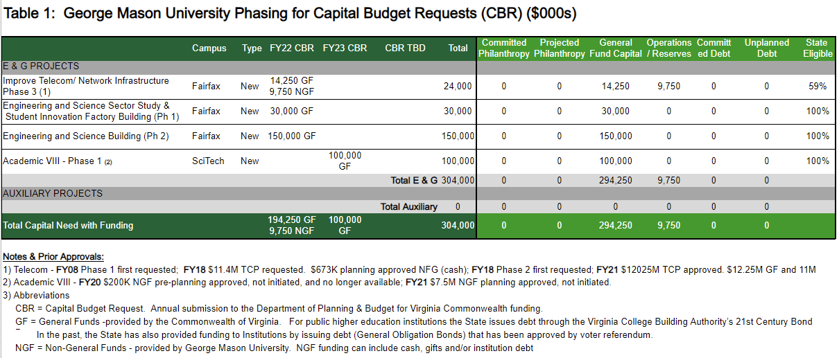

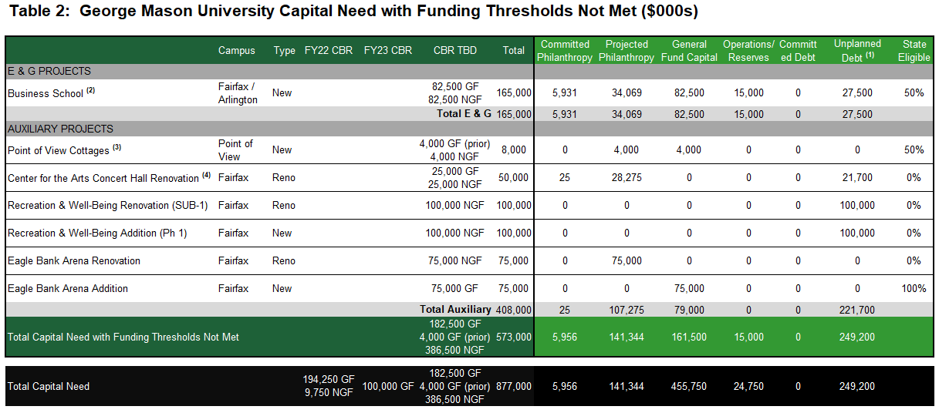

Improve Telecom Network Infrastructure Phase 3 ($24M)
This project will be the culmination of a multi-phased upgrade to the telecommunications infrastructure across of the University’s 119 buildings on all campuses. Each phase has built upon each other to eliminate single points of failure and increase network speeds through an expanded Wi-Fi network. The building upgrades in each phase consisted of telecommunication room upgrades, including electrical, air conditioning, and equipment racks to support power over Ethernet network switches and uninterruptible power supply systems; data network cable upgrades to allow for one-gigabit throughput to the desktop and 802.11ac Wi-Fi access points; and the equipment necessary to support the throughput. The current pandemic has magnified the need for a reliable and robust network to support remote education and allow the University to refocus our capital planning with the creation of a comprehensive master plan. It is envisioned that the expanded offering of remote learning will continue well beyond the pandemic. The University requires the infrastructure to support that need. Phase 3 will address the infrastructure in the buildings not addressed in Phase 1 or 2. It will also include physical upgrades to the infrastructure to create an encompassing exterior Wi-Fi and/or 5G network to support the continued learning of our students, the mission of accessibility of the University, and the potential to further activate the natural environments of the campuses. Drawing from the direction of the Master Plan, Phase 3 will evaluate opportunities to include pathway for future building sites. Finally, As Mason continues to grow our research portfolio the need for high-performance computing grows as well. Phase 3 will support the growth of the access to high-performance computing.

Engineering & Science Sector Study ($30M, including Student Innovation Factory Building below)
Mason’s 20-year Master Planning study identified significant laboratory, project and instructional space need on Fairfax campus for the College of Engineering and Computing (CEC) and the College of Science (COS). This need is further amplified by Mason's strategic vision developed as part of the Master Plan to consolidate undergraduate education in these disciplines through relocation of programs from the SciTech campus to the Fairfax campus. Additionally, the Master Plan includes significant circulation enhancements with a central pedestrian corridor traversing the primary axis of the campus which is presently impeded by David King and Planetary Halls, both CEC/COS buildings with critical facility condition indices. Removal of these 2 aging structures could additionally provide opportunities to incorporate sustainable design and current active-learning environments, which would not be as cost effective through renovation. The Engineering and Science Sector Study will leverage Mason's 20-year Master Plan to further refine these planning concepts and provide an actionable phased implementation plan addressing the following:
- Relocation of undergraduate CEC & COS programs from SciTech to Fairfax
- Replacement of David King and Planetary Halls
- Plan for current and future CEC and COS space needs as determined by the Master Plan

Student Innovation Factory Building ($30M, including Engineering & Science Sector Study above)
The Student Innovation Factory Building in Fairfax will be the first of several phases to be identified in the implementation plan for the Sector study. Planning will proceed through compilation of project performance-based requirements in a DPP and then construction of the Student Innovation Factory Building based on the DPP. The Student Innovation Factory Building will be an industrial-style pre-engineered or equivalent building to house student project space as required by CEC and COS for capstone coursework and student competition project work (e.g. concrete canoe, bridge, robotics, solar car, Baja car), and other large format student design and innovation projects. It will be a single story, high-bay, flexible, open warehouse space, suitable for developing and testing of land-, air- and water-based student projects. This space is presently included in SciTech's Life Science & Engineering Building (LSEB), which includes plans for transition of the vacated LSEB space on SciTech to graduate student use upon completion of the Student Innovation Factory Building on Fairfax.

Engineering & Science Building ($150M)
The Engineering and Science Building in Fairfax will be the second of several phases to be identified in the implementation plan for the Sector study. The project will be designed to budget in anticipation of additional phases to satisfy the goals of the Engineering and Science Sector study. Program goals for this phase will prioritize relocation of undergraduate CEC & COS programs from SciTech to Fairfax. The remainder of the building program will address the significant academic laboratory deficit on the Fairfax campus identified during the 20-year Master Planning study. This building will include flexible academic, office and laboratory spaces in support of these program goals which may additionally begin future phased replacement of David King and Planetary Halls. Because the intended space use for the Engineering & Science Building (Phase 2) is distinctly different than for the Student Innovation Factory Building (Phase 1), the DPPs for these two projects may be completed concurrently, pending funding availability.

Academic VIII ($100M)
The original project scope for Academic VIII was based on undergraduate growth projections, under a prior campus leadership team who envisioned Mason’s SciTech campus as a full-service stand-alone predominantly undergraduate campus. Since then, the developing 20-year Master Plan has reimagined the identity of SciTech as a predominantly graduate and research campus. As a result of the target student population change, the Life Sciences and Engineering Building (LSEB), presently in design, and Academic VIII, pending planning, have had a significant programmatic revision. Upon completion of the 20-year Master Plan, the campus Strategic Plan and LSEB reprogramming, Mason will be prepared to evaluate remaining program needs, growth projections and strategic research priorities envisioned for the next 20 years, and this will form the revised basis for planning of Academic VIII. Although Academic VIII will retain its original vision for an interdisciplinary science and engineering laboratory building, Mason anticipates that the original 200,000 GSF project scope for will exceed projected near-term program needs for these disciplines. Consequently, this project will be phased in two parts with the balance of the project scope reserved for a future Medical School, upon identification of a partner for this new program.

SECTION J: Restructuring: Provide information about any plans your institution has to seek an increased level of authority, relief from administrative or operational requirements, or renegotiation of existing management agreements.
RESPONSE:
In March 2021, Virginia Gov. Ralph Northam signed legislation that approved George Mason University as a Level III (or Tier 3) institution under the Restructured Higher Education Financial and Administrative Operations Act of 2005 (the Restructuring Act). Tier 3 is for the highest level of institutional management autonomy granted to Virginia public colleges and universities, a milestone achievement for Mason, the state’s youngest public research institution. Mason successfully met the statutory fiscal management performance standards required to attain the operational and administrative autonomy, including earning an issuer rating of Aa3 from Moody’s Investors Service in October 2019, demonstrating strong financial management and stewardship. The University has continued to demonstrate great gains in efficiency and effectiveness and with the additional authority, the University will continue its growth trajectory for ongoing success.
The Tier 3 management agreement offers Mason greater autonomy in financial operations, including capital projects, procurement, information technology, and human resources. The new agreement, passed by the General Assembly in February and signed by the governor in March, takes effect July 1, 2021. Mason becomes the sixth Virginia institution to attain Tier 3 status since the state passed the Restructuring Act, joining the University of Virginia, Virginia Tech, the College of William & Mary, Virginia Commonwealth and James Madison.
Prior to achieving Tier 3 status, Mason received Tier 2.5 authorization in 2016, at which point the University entered a five-year pilot program under the Restructuring Act, with a memorandum of understanding expiring on June 30, 2021.
Mason will spend the next year focusing on the Tier 3 implementation plan, including assessing additional strategic opportunities as a Tier 3 university in the ever-changing higher education environment. Highlights of the current operating autonomy and future opportunities include, but are not limited to, the following:
Capital Projects - the University is pursuing establishment of a local building department, including the appointment of a Virginia certified University Building Official (UBO). This position will act as the Authority Having Jurisdiction (AHJ) and will be the executive official in charge of enforcing the Virginia Uniform Statewide Building Code. The department will be named Office of the University Building Official and will require necessary support staff consisting of Virginia certified technical code examiners/permit administrator. After a transition period, this restructuring will remove the requirement to use Department of Engineering and Buildings (DEB) as the AHJ.
Information Technology - retain existing benefits under Tier 2/Tier 2.5 including authority to make decisions governing information technology, strategic planning, expenditure reporting, budgeting, project management, infrastructure, architecture, ongoing operations, security and audits within the University without engaging VITA or the VA CIO.
Procurement – continued autonomy with procurement functions and increasing discretion regarding university procurement guidelines, policies and procedures including increased institutional-level authority for the disposition of surplus and retention of all proceeds, localized decision-making in order to utilize cooperative contracts from other institutions and agencies, and reduced travel restrictions, purchasing card (p-card) and other expenditure documentation and procedure requirements.
Human Resources - provides Mason the flexibility to create a “university employee” classification with enhanced opportunities to attract, recruit and retain top talent, as well as the ability to design classification/compensations, adjust performance evaluation cycle, design leave categories, and offer benefits outside of the Commonwealth’s plan.
Financial Operations –
- Financial management opportunities for Mason to develop and refine policies resulting in strategic procedures that compliment efficient and automated processes as part of financial framework transformation plan.
- Financial resource retention and increased flexibility, which allows Mason to make weekly deposits to the Commonwealth, rather than daily deposits, or adjust daily deposits to lag by a week.
  - a Treasury Management Office is in development, where a central bank is in place with internal lending policies in process of implementation. During FY22, there will be additional treasury management operations and investments of local funds to generate funds for strategic investment;
  - with changes in deposit timing and expanded financial autonomy, Mason will have greater operating flexibility and the ability to optimize our investment management approach with the potential for higher earnings and increased funding for initiatives, as well as there are opportunities to achieve operational efficiencies for Mason and the Commonwealth by reducing the volume of transactions and reconciliations.
- Debt management – Mason will have the ability to issue debt without obtaining legislative authority resulting in faster and more efficient access to capital via the ability to enter debt and financing vehicles as needed (with BOV approval).

Section K. Evaluation of Previous Six-Year Plan: Briefly summarize progress made in strategies identified in your institution’s previous six-year plan. Note how additional general fund support and reallocations were used to further the strategies.
Provide Affordable Access for All Students
Since 2008, Mason has consistently enrolled half of the Pell populations of the northern VA area attending a 4-year public institution. As Fairfax and the surrounding counties continue to see population growth, Mason will continue to enroll a substantial proportion of those students. While Mason receives the second largest amount of Virginia Guaranteed Assistance Program (VGAP) funding, Mason has the lowest average grant packages compared to our VA public peers. The reason for this is Mason enrolls more low-income students than any other institution in the Commonwealth and pursues a strategy of helping more students with some assistance rather than fewer students with larger awards.
Mason increased institutional aid for all students by $5M in FY20 and in FY21, despite operating under pandemic conditions, with tuition revenues coming in below plan, budget reductions and increased covid-related costs, we increased institutional aid by another $6M. Our commitment to maintaining and enhancing affordable access for all students is a bedrock principle. For FY22, we did not increase undergraduate tuition in recognition of the financial hardships that our students continued to face as we recover from the economic impact of the pandemic; we increased institutional aid by $6.6M to meet the financial needs of our most vulnerable students and to continue to reduce the level of unmet need. We are very grateful that the Commonwealth allocated an additional $6.95M in FY22 State Financial Assistance, a 23% increase over our FY20 allocation, in recognition of Mason’s higher proportion of low-income, high need students.
Compensation
Over the past year, Mason, with the assistance of an outside consulting firm, conducted a faculty equity study to assess compensation practices. A project focused on faculty compensation has been initiated. As a result, in partnership with each academic unit, Mason is developing a discipline-based salary structure that will have market competitive ranges. The new model will provide the tools needed to conduct comprehensive faculty compensation analyses and will provide a framework to address issues such as compression, inversion, internal and external alignment. We are also working on a staff market/equity analysis to develop a framework for address salary compression and inequity.
In FY22, Mason will allocate the state-authorized salary increase of 5 per cent, on average, for teaching and research faculty, administrative and professional faculty, and classified staff and evaluate the effect of the raise relative to our SCHEV peer group and R1 institutions. Compensation studies will be conducted for faculty and staff to look at internal and external alignment, including market analysis.
Enrollment Growth
Despite the pandemic, Mason only missed our 2019 2B submission Planned Headcount target by 1.7% -- most of that enrollment stress was as a result of sluggish new freshmen enrollment. During the last several terms, however, Mason’s credit hour production has exceeded previous year’s totals and the university grew by more than 1.7% year-over-year last Fall. The university looks to grow again in Fall 2021, exceeding targets for new Freshmen and in all sectors of Graduate enrollment. We expect continued stress amongst our transfer market as key two-year feeder institutions experience enrollment declines.
Elevate Research & Research of Consequence
Mason’s research programs have continued to experience growth. Mason’s research expenditures increased from $114M in FY17 to $221M in FY20. Along with this tremendous growth, additional HEETF allocations are needed for research equipment. The university has been successful in obtaining some research instrumentation through federal sources but remains under-resourced for an institution of Mason’s size and scope. Mason’s three university level institutes, the Institute for Biohealth Innovation (IBI), the Institute for a Sustainable Earth (ISE), and the Institute for Digital InnovAtion (IDIA – launched in 2020) continued to catalyze new discoveries across disciplinary boundaries supported by the Commonwealth (IBI, $1.25M/year) and the university (ISE, $500,000/year; IDIA, $500,000/year). The institutes are making tremendous progress and can become a lot more impactful with the Commonwealth support.
Support New Faculty Hires & Emergency Retention Funding
There has been a steady growth of approximately 8% in I/R faculty hires since 2018. Like many institutions, Mason lost ground in faculty hiring during the COVID pandemic. We plan to make strategic faculty hires to get us back to our pre-pandemic hiring levels of instructional and research faculty annually to meet our strategic enrollment growth goals in targeted disciplines. We have experienced strong STEM-H enrollment growth in the College of Engineering and Computing and the College of Health and Human Services which is expected to increase the university’s research and innovation productivity. In 2018, 2019, and 2020, Mason spent over $1,000,000 in retention dollars as part of an effort to retain top talent.
Student Success Initiatives:
Student Experience Redesign Updates and additional initiatives: To serve an increasingly diverse student population, Mason is enhancing its student success initiatives, including implementing a collaborative coaching/advising model; enhancing overall well-being and mental health initiatives; increasing anti-racism and inclusive excellence initiatives that will increase academic success, enhance retention and strengthen four/six-year graduation rates. Another outcome of this redesign is to further instill a sense of belonging and pride among our students. The Student Experience Redesign initiative creates an integrated system of people, processes and technologies that support a comprehensive student care network. The planning process started in 2016 with six workstreams including an integrated coaching/advising system, physical and virtual student care network, and a constituency relationship management (CRM) system.
2020 – updates
Six year completion rates have increased over the past 5 years (2010-2016 – 69.8%; 2011-2017 – 70.8%; 2012-2018 - 70.0%; 2013-2020 - 70.7%; 2014-2020 – 71.6% Additionally, students’ sense of belonging and pride relative to being a Mason Patriot has increased in recent years: I am proud to be a Mason student: 2018:90%, 2019:89%, 2020:91%; I feel like I belong at Mason: 2918:86%, 2019:85%, 2020:87%; Mason is a welcoming place: 2020:93% (percentages reflect those that agree/somewhat agree)
Accessible Pathways
Over the past two years, Mason has exceeded our original expectations with the NOVA/ADVANCE transfer pathway, with more students signing a transfer agreement than was initially modeled. The two institutions have shared governance and financial responsibility for this program and have committed significant resources (approximately $2M) to launch and maintain this innovative initiative. Despite this significant investment, a greater share of technical resources must be brought to bear in order to remove many of the barriers still in front of students. When surveyed, students in the program cite the access to a dedicated Success Coach and simplified Admissions/Aid processes as the reason they are satisfied with their participation.

 | Fall 2018 | Spring 2019 | Fall 2019 | Spring 2020 | Fall 2020 | Spring 2021
TOTAL ACTIVE ADVANCE | 111 | 298 | 664 | 1100 | 1759 | 2140
Not Co-Enrolled at Mason | 109 | 283 | 625 | 1020 | 1529 | 1807
Active at Mason | 2 | 15 | 39 | 80 | 230 | 333

New Academic Programs
Accomplishments from 2019 – 2021
Following its approval in May, Mason launched a contemporary School of Computing – the first in the Commonwealth of Virginia – which will advance state-of-the-art research and scholarship in computing and related domains within and across all of Mason’s academic units, while leveraging resources in the Mason Institute for Digital Innovation. The new school—which will continue to meet and advance the needs for the Tech Talent Investment Program—will be housed with the existing Volgenau School of Engineering in Mason’s newly-created College of Engineering and Computing.

- Mason submitted and was approved for the following programs: MS in Finance, MS in Kinesiology, MS in Learning Design and Technology, BS in Sport Management, BS in Recreation Management, Graduate Certificate in Special Education, Graduate Certificate in Tactical Athlete Strength, Conditioning and Injury Prevention, Teaching English to Speakers of Other Languages (TESOL) for Practitioners PK-12, Undergraduate Certificate in Food and Beverage Management, Undergraduate Certificate in Early Childhood Education PK3, Undergraduate Certificate in Secondary Education English, Undergraduate Certificate in Secondary Education Mathematics, Undergraduate Certificate in Secondary Education Biology, Undergraduate Certificate in Secondary Education Chemistry, Undergraduate Certificate in Secondary Education Physics, Undergraduate Certificate in Secondary Education Earth Science, MS in Cyber Security Engineering, PhD in Public Health, BS in Health Informatics, Graduate Certificate in Science Communication, Graduate Certificate in Spanish Heritage Language Education, Graduate Certificate in Strategic Trade, Graduate Certificate in Public Management, Graduate Certificate in Science, Technology, and Security, Graduate Certificate in Music for Well-Being, Graduate Certificate in Art Education Licensure

Online Degrees
The pandemic has helped facilitate the adaptation of a predominantly face-to-face model of instruction to a model that is nearly entirely online. As we emerge from the depth of the public health crisis, we will continue to plan for a “new normal” with respect to the design and delivery of our academic programs. This will require that we review, refresh, reinvent, and reset our approach to course delivery and modality of instruction in ways that leverage and lift the experience of faculty, staff, and students who have engaged in online and hybrid instruction. At Mason, we are also focused on student support side of online programming. The provost charged a group to work in collaboration with academic unit administration and members of the Mason faculty to make recommendations and resourcing requests for the successful delivery of online academic programs. The goal of this process is to accelerate the integration of online programs and associated student services.

Section L. Diversity, Equity and Inclusion (DEI) Strategic Plan: Provide an update on the completion status of your institution’s plan that is being coordinated with the Governor’s Director of Diversity, Equity and Inclusion. If a copy of the plan is available, please include it when your institution submits its initial plan. If a copy of the plan is not available for July 1 or if changes are made, please provide a copy with your institution’s final plan submission on October 1
RESPONSE:
“George Mason University will become a national exemplar in anti-racism
and inclusive excellence.”

On June 1, 2020, in a statement to the Mason community, incoming President Greg Washington and Interim President Anne Holton issued a joint message declaring their firm commitment to social justice and racial equity on campus. In that statement they wrote, “in the wake of George Floyd’s murder, words are failing all of us. When leaders reach for words like outrage, horror, or despair, they only do more damage when they are not matched by action.” They then pledged “no words without action” and directed senior leadership to conduct a thorough review of Mason’s policies, practices, and procedures to identify systemic racism and begin the process of reconciliation.

In keeping with that pledge, one of Dr. Washington’s first official acts as president was to establish the President’s Anti-Racism, Inclusive Excellence (ARIE) Initiative, where he appointed a thirty-one-member taskforce and charged them with working to eradicate practices and traditions of racial bias at Mason, and positioning the University as a national beacon for the advancement of anti-racism, reconciliation, and healing. He also announced a $5 million investment over a three-year period for the ARIE work.

Vision: George Mason University will become a national exemplar of anti-racism and inclusive excellence.
Mission
- Develop and implement effective systems, practices and traditions that eradicate racism and bigotry at Mason.
- Prevent racist practices from regenerating through the establishment.
- Establish Mason as a community, commonwealth, regional, and national resource for the advancement of anti-racism, reconciliation, and healing.

Tenets:
- Mason will be deliberate in establishing an inclusive environment in which all members of the campus community are welcomed and supported; experience a sense of belonging; and differing perspectives are valued and encouraged.
- Mason is committed to equal opportunity across the board, and will aggressively challenge and respond to bias, discrimination, and harassment.
- Anti-racism and inclusive excellence will be foundational in every program, process, policy, and procedure at Mason.

The Taskforce membership represented the full diversity of Mason including racial, ethnic, gender, differently abled, sexual identity, and religious identity. The scope of their work was broad and divided among six committees, consisting of 110 members of Mason’s faculty, staff, students and alumni.

- Training & Development: Charged with enhancing, developing, recommending, and integrating anti-racism and inclusive excellence training throughout the campus.

- Campus & Community Engagement: Charged with developing, implementing, and supporting programs that promote access, diversity, equity, and inclusion through campus and community partnerships.

- University Policies and Practices: Charged with identifying systemic inequities within Mason’s policies, practices, processes, and procedures to enable needed change. Further, the committee was charged with developing and implementing an action plan for achieving meaningful, long-term structural change and accountability throughout the university community.

- Curriculum & Pedagogy: Charged with recommending, helping to develop, and/or expanding current curriculum that prepares students to not only understand and address systemic racism and values a multicultural world, but also a curriculum that is intentionally inclusive of the diverse scholars and voices that contribute to the academy.

- Student Voice: Students often experience racism and bigotry in the university setting differently than faculty and staff. While students were included on the larger taskforce, the student voice committee allowed for more input from student leaders from across the university on the student experience and campus climate. Student voices supported and enhanced the work of the ARIE and engaged other students in its work.

- Research: Charged with promoting an inclusive community that advances the meaningful contributions of diverse perspectives and views ​to the research, scholarship and creative activities of the campus community. The committee established guidelines and worked with colleges and schools to promote diversity and inclusion in all areas of research​, scholarship and creative activities across campus. Additionally, they were charged with establishing programs, opportunities and formal mentorships to increase historically underrepresented candidates. ​

After six-months of work, the taskforce and committees submitted sixty-two recommendations to advance anti-racism and inclusive excellence at Mason. They prioritized the top 15 as a beginning point for implementation. These priorities were presented to and received feedback and broad support from the Board of Visitors. They were also presented to the Mason community at two campus-wide townhalls where over 1000 people participated. All feedback received from the Board of Visitors and the townhalls were incorporated into the recommendations that follow.
The ARIE Initiative is now in the implementation phase with fifteen senior-leveled members, including the chief-of-staff, are charged with turning the recommendations into action.
One Virginia Goals: George Mason University

GOAL 1
Access and Success: Achieve and maintain a more diverse and inclusive undergraduate and graduate/professional student body, faculty and staff, and administration.
Objective 1: Recruit, hire and retain faculty, administrative and professional faculty, and staff to reflect our student population
Possible Strategies:
- Identify gaps to determine how the demographic diversity of Mason’s I & R faculty, A&P faculty and staff compares to the student population
- Create and implement comprehensive inclusive hiring process that includes:
- ARIE search training for each type of search (IR, AP, classified staff, etc.);
- Inclusive search plans to document search;
- Process for certifying diversity of applicant pool (HR-provided data);
- Diversity cluster hire initiatives across the university;
- Central funding to support diverse sourcing and advertising of open positions;
- Equitable and competitive compensation packages
- Form working group to design comprehensive retention initiative.
- Create committee with faculty senate and other stakeholders to examine annual review and revision of RPT criteria.
Metrics and Indicators:
- Implement comprehensive inclusive hiring process (modeled on CHSS, VSE, and other applicable units) and launch diversity cluster hire processes across colleges and schools
- Working group launches comprehensive retention initiative
- Adoption of annual review and RPT criteria
Objective 2: Elevate services for students that support inclusive excellence, diversity, and anti-racism
Possible Strategies:
- Improve effectiveness, response time, and physical layout (to ensure privacy) of Student Services Center (e.g., for financial aid).
- Increase outreach, funding, and support for students from historically underrepresented groups
- Reassess cost, coverage, and support services for health insurance for all students
- Establish policies for equity in hiring, workload and supervision of undergraduate student employees (work-study, wage, stipend) and graduate student employees (assistantships, lectureships, hourly, and adjuncts)
- Implement universal accessibility requirements for academic activities (syllabi, classrooms, learning materials, equipment, etc.), extracurriculars & events
Metrics and Indicators:
- Student Services Center improvements implemented
- Inclusive Excellence plans for each college/school include strategies for recruitment (internal and external) and support diverse population of graduate students.
- Commit funds to support recruit and fund graduate students from historically underrepresented groups
- Comprehensive review (with peer comparisons & discussions with student government & GAPSA) and improvement plan of cost and coverage of student health insurance completed
- Climate Survey Committee ensures inclusion of questions regarding equity in hiring, workload and supervision of undergraduate and graduate employees
- Universal accessibility requirements finalized

GOAL 2
Climate and Intergroup Relations: Create and sustain an organizational environment that affirms and respects diversity and employs inclusive practices throughout its daily operations.
Objective 1: Charge the University Naming Committee with reviewing honorary naming policies and recommend updates that ensure clarity of intent and procedures are in place when naming, de-naming, or re-naming campus buildings, rooms, and open spaces aligned with the university’s justice-oriented goals and values
Possible Strategies:
- Expand composition of this committee to include faculty, students, alumni, staff, and representation from the Mason Legacies Center
- Begin review of existing named buildings and spaces
- Submit renaming proposals of existing buildings and spaces to University. Leadership.
Metrics and Indicators:
- University Leadership approves renaming criteria.

GOAL 3
Education and Scholarship: Engage students, faculty, staff, alumni, and the community in learning varied perspectives of domestic and international diversity, equity, inclusion, and social justice.

Objective 1: Provide opportunities for faculty and staff to build competencies in diversity, equity and inclusion in order to build awareness of unconscious bias and create a culture of inclusive excellence across the entire community.
Possible Strategies:
- Determine resources required to deliver and evaluate the training, including but not limited to Intercultural Development Inventory (IDI) (e.g., certified trainers, assessment needs)
- Identify and define faculty and staff competencies
- Conduct an audit to develop a catalog of existing diversity, equity, inclusion, and anti-racist training programs.
- Map existing courses to the competencies.
- Develop curriculum to fill gaps in existing training.
Metrics and Indicators:
- Number of faculty and staff who have completed training.
- Training programs offered build DEI competencies for faculty and staff.
- Campus IDI Assessment shows positive increases in faculty and staff scores.
Objective 2: Pilot foundational “Introduction to Anti-Racism Inclusive Excellence (ARIE)” workshop.
Possible Strategies:
- Develop content for introduction to ARIE workshop that is tailored to various audiences (faculty, staff, supervisors).
- Select a diverse institution-wide group of faculty and staff participate in and review the training.
- Create Train-the-Trainer materials, including facilitator guides and learning materials.
- Develop and implement a roll-out plan for the revised pilot workshop.
Metrics and Indicators:
- Foundational ARIE workshop offered to faculty and staff during on-boarding.
- ARIE workshop is offered via multiple modalities in order to extend the reach to a broad base faculty and staff.
Objective 3: Create an Anti-Racism and Inclusive Excellence Certificate Program, which will be offered to all Mason faculty, staff, and students.
Possible Strategies:
- Develop a philosophy statement for the certificate program, including learning objectives and outcomes.
- Hire a Training Lead, reporting to the Office of CDE to manage.
- Incentivize participation through the Inclusive Excellence plans developed at the unit level.
- Partner with Stearns Center for Teaching & Learning/Organizational Development & Learning/Carter School to develop curriculum and syllabus.
- Utilize currently developed training.
Metrics and Indicators:
- Training lead successfully launches Certificate Program.
- Increased enrollment in ARIE Certificate program year after year.
- Other institutions adopt the ARIE Certificate program.
Objective 4: Implement Student-Requested Foundational Course on Diversity and Inclusion titled Foundations for Building a Just Society.
Possible Strategies:
- Support launch: Support faculty leadership team who will refine the newly piloted and CORE-approved course, teach 7 sections in Fall 2021, and begin training and development materials for anticipated scaling up​
- Propose request: Propose making this course a requirement for all undergraduate students through submitting proposal to Mason Core, Academic Policies, and Faculty Senate​
- Hire admin staff: Hire program director and administrative coordinator to scale up course
- Meet need for faculty: Identify/hire faculty who will teach this course, do scholarship, and mentor graduate students in scholarship related to diversity, equity, and inclusion across disciplines​
Metrics and Indicators:
- At least 150 students enrolled in Fall 2021
- Team is supported with stipends
- Team creates revised syllabus and materials for scale up
- Student surveys/focus groups conducted to ensure sustainability and impact
- Proposal submitted to required bodies (Mason Core, Academic Policies, and Faculty Senate​)
- Recruitment and onboarding of staff
- Number of full-time faculty teaching course meets student need as course scales up.
Objective 5: Develop a research seed funding initiative focused on anti-racism and inclusive excellence to promote and support diversity and inclusion through multi-disciplinary research, scholarly and creative projects
Possible Strategies:
- Define criteria to determine if research focuses and promotes DEI
- Issue request for proposals
- Notification and start of first-round awards
- Awardees’ mid-project and final activity report
Metrics and Indicators:
- Five-ten (5-10) projects will be awarded per year
- Inclusion of undergraduate and graduate student researchers on projects
- Project reports on how seed funding supported diversity and inclusion
Objective 6: Develop a graduate-level mentored research, scholarship, creative and commercialization program to provide more funded opportunities for students with a demonstrated commitment to critically engaging anti-racist scholarship
Possible Strategies:
- Issue request for proposals
- Notification of first-round awards
- Start of first-round awards
- Awardees’ mid project and final activity report
Metrics and Indicators:
- Five-ten (25-50) projects per round, two rounds per year
- Diverse graduate student researcher participation on projects
- Celebration of projects at the end of Fall 2022
Objective 7: Host a nation-wide event to highlight multidisciplinary academic research and practices around anti-racism, diversity, and inclusive excellence
Possible Strategies:
- Registration. opening
- Event date
- Video of event’s highlights
Metrics and Indicators:
- Number of participants
- Event satisfaction survey
- Number of sponsors

GOAL 4
Infrastructure and Accountability: Create and sustain an institutional infrastructure that effectively supports progress and accountability in achieving DE&I goals.

Objective 1: Build university wide infrastructure to promote and enhance Anti-Racism, Diversity, Equity, and Inclusion
Possible Strategies:
- Propose revised organizational structure to support and sustain Anti-Racism, Diversity, Equity, and Inclusion Across the University
- Create Institutional Definitions of Diversity, Equity, Inclusion, Anti-Racism, and Inclusive Excellence
- Update Comprehensive Website (Under Purview of New DEI Office) for DEI Initiatives, University progress reports, Resources, Contacts & Events
- Prepare Other Critical Related Initiatives: 1) Campus Climate Survey for Specifically Geared Toward Incidents of Inclusion, Exclusion, Forms of Discrimination and Violence, Retaliation, Modes of Resolution, and Support needs; 2) Review of Business and Labor Practices; 3) Comprehensive Bias Reporting and Support Services System with Improved Data Collection and Management
Metrics of Success:
- Academic units submit Inclusive Excellence plans
- Onboarding of VP of Diversity Equity & Inclusion
- Administrative units submit Inclusive Excellence plans
- Identify and Fill strategic vacancies
- Adoption of University wide definitions of Diversity, Equity, Inclusion, Anti-Racism, and Inclusive Excellence Updated Comprehensive website launched
- Framework for bi-annual progress reports established (DEI Office, OIEP, HR, Admissions, etc.)
- First annual report prepared by President’s Office completed and posted on the website
- Campus Climate survey and Business and Labor Practices Review completed
- Approved plan for Comprehensive Bias Reporting and Support Services System
Objective 2: Expand Antiracist and Inclusive Excellence Curriculum and Pedagogy beyond Foundations Course through Instructor Support, Capacity Building, Curriculum Review and Teaching Evaluation​
Possible Strategies:
- Support Instructors in Improving their Teaching: Stearns Center/QEP faculty team for Teaching Resource Development will create new ARIE materials & workshops, and recommend antiracism language for syllabi across disciplines.
- Build Capacity of Stearns Center for Teaching & Learning: Hire antiracist education specialist, faculty fellows, and grad/undergrad assistants in Stearns Center to help lead, coordinate, and assess both faculty support and existing DEI offerings university-wide.
- Ensure Diversity and Inclusion across the Curriculum: Antiracist education specialist spearheads work with colleges and departments to review course catalogue, ensuring programs have at least one course/section that addresses these issues​.
- Revise Student Evaluations of teaching include items about inclusiveness (Faculty Senate & Effective Teaching Committee) ​
Metrics and Indicators:
- Creation of resources; Faculty attendance at development workshops; course and curriculum reviews/revisions completed; follow-up surveys/focus groups about pedagogical implementation
- Successful hiring of Stearns Center faculty fellows, assistants and anti-racist education specialist
- Course review completed; list of DEI courses published on website; unmet curriculum needs identified
- Student evaluations of teaching include items about inclusiveness.
Objective 3: Provide Support and Incentives to Expand and Sustain ARIE
Curricular Efforts​ through Stipends, Mini-Grants and Guidelines for Faculty Recognition
Possible Strategies:
- Provide stipends for faculty participating in workshops​
- Create mini-grants and other incentives supporting course development, materials creation, and other collaborative long-term curricular and faculty development efforts, including development of interdisciplinary capstones​
- Consult with peer institutions on the development of guidelines for promotion and tenure to recognize and reward teaching and research efforts related to antiracism, equity, and community engagement ​
Metrics and Indicators:
- # of faculty supported in attending workshops, # of local academic units with faculty who are supported in attending
- # of local academic units that have incorporated anti-racist teaching and curriculum development into their faculty evaluation or recognition systems;
- # of applicants and # of mini-grants awarded to faculty for curriculum development
- Report generated and presented to relevant Mason bodies.

GOAL 5
Community Engagement: Leverage institutional philanthropy and community partnerships to improve outcomes in local and regional communities.

Objective 1: Establish a new Police Advisory Board to work with the Police Department that will enable the analyses of policies, practices, procedures, and data to enhance equitable policing procedures, processes, accountability, and communication
Possible Strategies:
- Establish and launch a diverse advisory board that mirrors the university demographics.
- Board conducts analysis of policing procedures, practices, and policies and submits initial report to GMU President.
- Implement new and approved equitable community policing policies.
- Enhance hiring and training within GMU police department
Metrics and Indicators:
- Campus climate survey documents greater satisfaction in campus policing by 50% per year among all university demographic groups.
- Reported greater sense of safety on campus in campus climate survey by 50% per year.
- Decrease in reported incidences of policing inequities and bias by 50% per year.
Objective 2: Strengthen and expand the Truth, Racial Healing, and Transformation Center (TRHT) to include a new Anti-Racism and Inclusive Excellence Lecture Series, K-12 and community partnerships centered on inclusive excellence and anti-racism, and alumni engagement opportunities.
Possible Strategies:
- Fund and hire a full-time director, program coordinator, graduate program assistant, and part-time administrative assistant.
- Provide a platform for existing signature campus events.
- Increase Mason’s capacity to develop meaningful, impactful, interdisciplinary, multidisciplinary educational programs with community members.
- Establish a TRHT Advisory Board comprised of faculty fellows, students, alumni, and community representatives
- Establish innovative partnerships with campus units to prepare students for global leadership.
- Launch a Community Advisory Board to review and advise on anti-racist community engagement initiatives
Metrics and Indicators:
- TRHT staffing hired and establishing partnerships and collaborations
- New lecture series launched
- Mason faculty, staff, students, alumni and local community representatives actively engaged in the vision and goals of the center

Section M. Economic Development Annual Report: Provide a copy of any report your institution has produced about its economic development contributions.
RESPONSE:

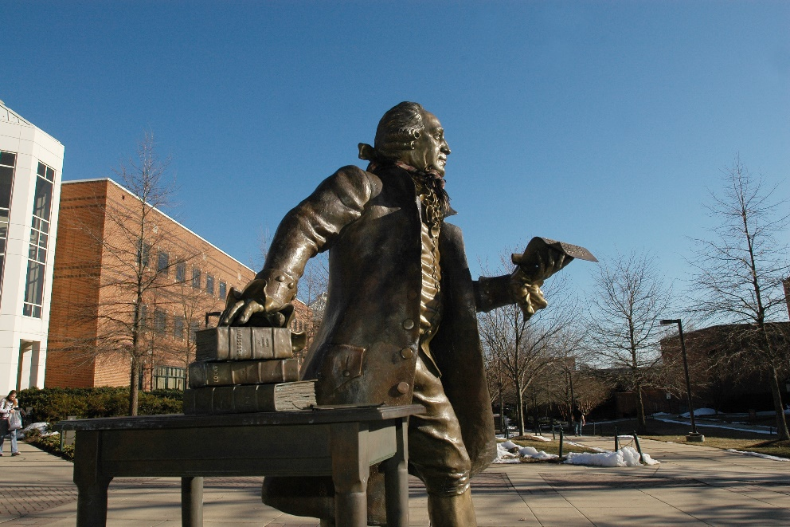

DRAFT
The Economic Contributions of George Mason University

December 18, 2020

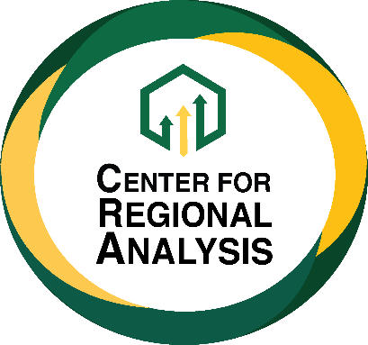

Acknowledgement page

The research team gratefully acknowledge the efforts by University Staff and Administrators for their contributions to their research

Economic Contributions of George Mason University
Commonwealth of Virginia
Fiscal Year 2020

Executive Summary

George Mason University continues to expand its significant impacts on the Northern Virginia region and across the Commonwealth of Virginia. In addition to being the state’s largest university serving over 37,000 students, GMU has in recent years risen to join the ranks of the nation’s most successful research institutions, played an important role in attracting Amazon HQ2 to the Commonwealth, and has emerged as the state’s largest contributor to its tech talent labor force. In this analysis, we examine the economic contributions of George Mason University through its budgeted expenditures and related spending on the state economy.

In estimating the university’s economic contributions, we include capital spending that supports growth and mission expansion, operations spending, student and visitor spending, and the operations of the GMU Foundation. Our analysis utilizes the IMPLAN economic input-output model that provides estimates of direct, indirect, and induced economic contributions. Direct impacts capture the spending by the university, students, visitors, and closely related entities. Indirect impacts represent economic spillovers that flow to vendors, contractors, and suppliers of goods and services to the university. Induced impacts come from staff, faculty, and employees of vendors spending a portion of their earnings in the Virginia economy. The contributions are expressed as total economic activity (a measure of business transactions), value added (gross state product), labor income (salaries, wages, and benefits), and employment (headcount jobs). In addition, the model provides estimates of state government revenues from taxes, fees and other sources, which we adjust to account for the university’s tax-exempt status.

The analysis is based on Fiscal Year 2020 data, which ended June 30, 2020. Total spending by key categories include:
- Capital expenditures totaled $85.2 million.
- Operations expenditures totaled $872.3 million.
- Student and visitor spending totaled $130.9 million.
- The GMU foundation spent $2.8 million for operations, not including funds transferred to GMU for scholarships and other support that are included in university spending.
Based on the analysis, recurring operations at the university and related spending generated $1.9 billion in economic activity in Virginia, increased total gross state product by $1.2 billion, and supported over 17,500 jobs that paid almost $925 million in salaries, wages, and benefits (see Table ES1). Even though the university does not directly pay taxes, its recurring economic contributions supported $33.7 million in revenue for state government in FY2020. In addition, the university’s capital spending in FY2020 exceeded $85 million, which boosted state economic activity by $138 million, increased total state product by $83.4 million, added $56.8 million in state labor income, supported over 900 jobs, and increased state tax revenues by $1.3 million. Combining operations and capital economic contributions, in FY2020, George Mason University created over $2 billion in statewide economic activity, increased gross state product by $1.3 billion, and supported over 18,400 jobs that paid $982 million in salaries, wages, and benefits. University operations and capital spending at GMU sparked over $35.0 million in new tax revenues for the Commonwealth of Virginia.

Table ES1
Economic Contributions of George Mason University
Commonwealth of Virginia
Fiscal Year 2020

Description | Contribution
University Operations
Output (business transactions) | $ 1,887,974,000
Value Added (gross state product) | $ 1,227,927,000
Labor Income (salary, wages, benefits) | $ 924,787,000
Employment (headcount jobs) | 17,526
State Tax Revenues | $ 33,707,000
Capital Spending
Output (business transactions) | $ 138,297,000
Value Added (gross state product) | $ 83,417,000
Labor Income (salary, wages, benefits) | $ 56,801,000
Employment (headcount jobs) | 904
State Tax Revenues | $ 1,302,000
Total
Output (business transactions) | $ 2,026,271,000
Value Added (gross state product) | $ 1,311,344,000
Labor Income (salary, wages, benefits) | $ 981,588,000
Employment (headcount jobs) | 18,430
State Tax Revenues | $ 35,010,000
Sources: GMU, IMPLAN, Center for Regional Analysis. Note estimate totals may not sum due to rounding.

The analysis considers the impacts of capital spending separately since capital programs are non-recurring. In practice, as Mason has continued to grow there has been substantial capital spending that has become effectively recurring in nature. From FY2011 through FY2020, GMU capital programs spent more than $743 million in inflation-adjusted 2020 dollars. This spending generated almost $1.2 billion in state economic activity, increased total value added by $718 million, increased total state labor income by $484 million and supported 7,740 person-years of employment (see Table ES2). Total state tax revenues associated with university capital spending during this period exceeded $11 million.

Table ES2
Economic Contributions of George Mason University
Capital Spending Program Fiscal Years 2011—2020
Commonwealth of Virginia

Description | Contribution
Output (business transactions) | $ 1,193,151,000
Value Added (gross state product) | $ 717,746,000
Labor Income (salary, wages, benefits) | $ 484,066,000
Employment (headcount jobs) | 7,740
State Tax Revenues | $ 11,191,000
Sources: GMU, IMPLAN, Center for Regional Analysis. Note estimate totals may not sum due to rounding.

Introduction

George Mason University is among the most important anchor institutions in Northern Virginia and the National Capital Region, with an increasing array of programs that touch businesses and communities across the Commonwealth of Virginia. Mason has grown from a branch campus to become the largest public university in Virginia with more than 37,000 students. The university has also recently joined the top tier of research universities and is now classified as an R1 university and boasts nationally and internationally recognized academic programs in a growing number of disciplines. George Mason has expanded its traditional role in providing accessible and affordable higher education to Northern Virginia families to being a major economic development asset to the region and state as exemplified by the attraction of Amazon HQ2. Beyond the important contributions of George Mason University as a key resource in developing talented workers and supporting broad-based economic development, it has also become a major regional employer with economic impacts that stretch across the region and state. This analysis examines the economic contributions of George Mason University through its budgeted expenditures and related spending on the economy of Virginia.
Using the latest best practices for assessing the economic contributions of public universities, this initial assessment includes four primary sources of impacts: spending on capital projects, university operations spending, spending by students and visitors, and operations spending by the university foundation. The analysis estimates the economic contributions of new spending that occurred as the result of the university’s presence using the IMPLAN economic input-output model.
The IMPLAN model, which is widely used in professional and academic research, provides estimates of direct, indirect, and induced economic effects. Direct effects are the impacts resulting from spending by the university, students, visitors, and the foundation. Indirect effects capture the successive rounds of spending sparked by direct spending. For example, a university vendor who supplies systems maintenance services hires employees, purchases parts and equipment, rents office space, and hires a bookkeeping service. In turn, the bookkeeper hires employees, purchases office equipment and supplies, and hires a janitorial service to clean their office, and so on. Induced effects result from university employees and the employees of vendors and contractors spending a portion of their earnings for goods and services within the study geography. At each stage of spending, the model adjusts for spending that leaks out of the regional economy, such as purchasing office supplies that are not manufactured in Virginia. When added together, the sum of the adjusted direct, indirect, and induced effects are often larger than the direct spending, which is the “multiplier” effect. Results of the impacts are expressed as total economic activity (a measure of business transactions), value added (gross state/regional product), labor income (salaries, wages, and benefits), and employment (headcount jobs). Additionally, the IMPLAN model provides estimates of state revenue from taxes and fees that are the result of the economic activity created by the university. Tax revenues are adjusted to account for the GMU’s tax-exempt status.

An overview of the university’s impacts is provided in the next section with more detailed findings offered in subsequent sections of the report.

Impact Overview

The analysis is based on Fiscal Year 2020 data, which ended June 30, 2020. Total spending by key categories include:
- Capital expenditures totaled $85.2 million.
- Operations expenditures totaled $872.3 million.
- Student and visitor spending totaled $130.9 million.
- The GMU foundation spent $2.8 million for operations, not including funds transferred to GMU for scholarships and other support that are included in university spending.
Based on the analysis, recurring operations at the university and the GMU Foundation, plus student and visitor spending, generated $1.9 billion in economic activity in Virginia, increased total gross state product by $1.2 billion, and supported over 17,500 jobs that paid almost $925 million in salaries, wages, and benefits (Table 1). Even though the university does not directly pay taxes, its recurring economic contributions supported $33.7 million in revenue for state government in FY2020. In addition, the university’s capital spending in FY2020 exceeded $85 million, which boosted state economic activity by $138 million, increased total state product by $83.4 million, added $56.8 million in state labor income, supported over 900 jobs, and increased state tax revenues by $1.3 million. In total, for FY2020 George Mason University and related spending generated over $2 billion in statewide economic activity, increased gross state product by $1.3 billion, and supported over 18,400 jobs that paid $982 million in salaries, wages, and benefits. These economic activities supported over $35.0 million in new revenues for the Commonwealth of Virginia.

Table 1. Economic Contributions George Mason University, FY2020
Description | Contribution
University Operations
Output (business transactions) | $ 1,887,974,000
Value Added (gross state product) | $ 1,227,927,000
Labor Income (salary, wages, benefits) | $ 924,787,000
Employment (headcount jobs) | 17,526
State Tax Revenues | $ 33,707,000
Capital Spending
Output (business transactions) | $ 138,297,000
Value Added (gross state product) | $ 83,417,000
Labor Income (salary, wages, benefits) | $ 56,801,000
Employment (headcount jobs) | 904
State Tax Revenues | $ 1,302,000
Total
Output (business transactions) | $ 2,026,271,000
Value Added (gross state product) | $ 1,311,344,000
Labor Income (salary, wages, benefits) | $ 981,588,000
Employment (headcount jobs) | 18,430
State Tax Revenues | $ 35,010,000
Sources: GMU, IMPLAN, Center for Regional Analysis. Note estimate totals may not sum due to rounding.

Supporting GMU’s growth over the past several years has required an impressive program of capital expansion for facilities and other resources. Traditionally, capital spending by universities is considered non-recurring. However, GMU’s growth trajectory is measured in decades. To get a better sense of the exceptional economic contributions resulting from capital spending at GMU campuses, we consider long run contributions over the past ten years. For the period FY2011 through FY2020, GMU capital programs spent over $743 million in inflation-adjusted 2020 dollars. This spending generated almost $1.2 billion in state economic activity, increased total value added by $718 million, boosted total state labor income by $484 million and supported 7,740 person-years of employment (Table 2). These contributions are expressed in inflation-adjusted 2020 dollars. Total state tax revenues associated with university capital spending during this period exceeded $11 million.

Table 2. Economic Contributions of Capital Spending to the Commonwealth of Virginia ($2020)
Description | Contribution
Output (business transactions) | $ 1,193,151,000
Value Added (gross state product) | $ 717,746,000
Labor Income (salary, wages, benefits) | $ 484,066,000
Employment (headcount jobs) | 7,740
State Tax Revenues | $ 11,191,000
Sources: GMU, IMPLAN, Center for Regional Analysis. Note estimate totals may not sum due to rounding.

Detailed Analyses

Capital Spending Impacts
Economic contribution studies report capital spending separately from operational spending given that capital projects are usually one-off in nature. For example, capital spending for a new classroom building ends once construction is completed – it is not recurring spending. In this report we hold to this traditional approach, while recognizing the combined contributions of recurring operations spending and the capital spending that occurred in the study year. However, GMU has been growing steadily for many years and has had multiple successful capital campaigns supporting continuing growth and development on the university’s campuses. In effect, GMU’s capital spending has been recurring. To illustrate the long-term contributions of university capital spending, we examined spending for the most recent fiscal year (FY2020) and total capital spending over the past ten years (FY2011-FY2020).

Capital Spending – FY2020
In fiscal year 2020, GMU spent $85.2 million on capital expenses (Table 3). The majority of expenses went directly to buildings, which cost the university $71 million in FY 2020. The university also spent $6.1 million on architecture and engineering, $4.0 million on furnishings, fixtures, and equipment, and $3.8 million on other costs, such as environmental impact analyses and other project support. Among the capital expenditures in FY2020 was an addition to Bull Run Hall, an addition to the Hylton Center, and a renovation at Robinson/Harris Hall.

Table 3. Capital Expenditures (FY2020)
Category | Expenditures
Soft Costs:
Architecture/Engineering | $ 6,096,636
Financing | $ -
Other | $ 3,851,716
Hard Costs:
Site Preparation | $ 196,495
Building | $ 71,053,566
Furnishings/Fixtures/Equipment | $ 4,002,631
Total | $ 85,201,044
Sources: GMU, Center for Regional Analysis

Capital spending by GMU generated $138.3 million in economic activity (output) in the Commonwealth of Virginia and boosted gross state product (value added) by $83.4 million (Table 4). Capital spending in FY2020 supported more than 900 jobs that paid approximately $56.8 million in salaries, wages, and benefits (labor income). Furthermore, the capital spending resulted in more than $1.3 million in state revenue through indirect and induced economic contributions.
Table 4. Economic Contributions of Capital Expenditures on Virginia (FY2020)
 | Employment | Labor Income | Value Added | Output | State Taxes
Direct | 583 | $38,706,000 | $51,256,000 | $82,239,000 | Tax Exempt
Indirect | 113 | $7,788,000 | $12,499,000 | $23,067,000 | $481,000
Induced | 208 | $10,308,000 | $19,661,000 | $32,991,000 | $821,000
Total | 904 | $56,801,000 | $83,417,000 | $138,297,000 | $1,302,000
Sources: GMU, IMPLAN, Center for Regional Analysis. Note estimate totals may not sum due to rounding.

Capital Spending – FY2011 to FY2020
From fiscal year 2011 to fiscal year 2020, Mason has spent nearly three quarters of a billion dollars on capital projects. Total capital spending from 2011 to 2020, in inflation-adjusted 2020 dollars, was $743.1 million dollars (Table 5). The majority over these expenses were on hard costs. Over this period, GMU spent $614.3 million on buildings, $43.4 million on furnishings, fixtures, and equipment, and $5.1 million on site preparation, such as leveling earth. The university also spent heavily on soft costs. Over the decade, Mason spent $52.5 million on architecture and engineering services, $17.2 million on other costs, such as environmental impact studies, and $10.7 million on financing.

While capital expenditures are typically reported separately as they do not reoccur annually, Mason’s growth has resulted in stable capital expenditures each year. Not adjusting for inflation, GMU spent an average of $68.7 million annually from 2011 to 2020. Capital spending ranged from $42.8 million in 2018 to $116.4 million in 2011. During most years, however, the university spent between approximately $55 million and $85 million.

Table 5. Capital Expenditures (FY2011 to FY2020 Total)
Category | Expenditures
Soft Costs:
Architecture/Engineering | $ 52,507,703
Financing | $ 10,700,840
Other | $ 17,186,785
Hard Costs:
Site Preparation | $ 5,059,570
Building | $ 614,261,937
Furnishings/Fixtures/Equipment | $ 43,388,899
Total | $ 743,105,733
Sources: GMU, Center for Regional Analysis. Note – Annual capital spending inflated to 2020 dollars.

From 2011 to 2020, capital spending by GMU spawned $1.2 billion in economic activity (output) in the Commonwealth of Virginia (Table 6). Capital spending boosted gross state product (value added) by $717.7 million. Capital spending in FY2020 supported 7,740 jobs that paid approximately $484.1 million in salaries, wages, and benefits (labor income). Furthermore, the capital spending resulted in roughly $11.2 million in state revenue through indirect and induced economic contributions.

Table 6. Economic Contributions of Capital Expenditures on Virginia (FY2011 - FY2020)
 | Employment | Labor Income | Value Added | Output | State Taxes
Direct | 4,984 | $328,596,000 | $441,474,000 | $710,998,000 | Tax Exempt
Indirect | 984 | $67,588,000 | $108,638,000 | $200,869,000 | $4,191,000
Induced | 1,771 | $87,883,000 | $167,635,000 | $281,284,000 | $7,000,000
Total | 7,740 | $484,066,000 | $717,746,000 | $1,193,151,000 | $11,191,000
Sources: GMU, IMPLAN, Center for Regional Analysis. Note estimate totals may not sum due to rounding.

Operation Impacts
Operations spending accounts for the largest portion of the economic contribution of George Mason University. In fiscal year 2020, the university spent more than $1.1 billion on operations. Line items such as scholarships and fellowships, nonstudent waivers and allowances, principal and interest payments were excluded. Net new spending that resulted from the universities presence that remained in the region totaled $872.3 million (Table 7). The greatest portion of operations expenditures is personnel costs, which for FY2020 totaled $426.1 million in salaries and wages and $128.5 million on fringe benefits that combined accounted for almost 68 percent of total operations spending. Other direct university expenditures categories include contractual services, travel, supplies, and continuous charges for electricity and sewage. Operations spending in these categories totaled $281.6 million in FY2020. Contractual services, such as computer support, facilities management, and landscaping services, accounted for $171.3 million.

Table 7. Operation Spending (FY2020)
Spending Category | Account | FY2020
Labor | Personnel | $462,058,220
Fringe Benefits | Fringe Benefits | $128,544,054
Direct Expenditures | Contractual Services | $171,347,693
 | Travel | $20,157,265
 | Supplies | $21,104,917
 | Merchandise-Resale | $9,555
 | Continuous Charges | $47,937,120
 | Furniture & Equipment | $21,098,082
Total |  | $872,256,906
Sources: GMU, Center for Regional Analysis

Operations at the university generated $1.7 billion in economic activity in the Commonwealth of Virginia and increased gross state product by $1.1 billion in fiscal year 2020 (Table 8). Operations spending by the university supported more than 16,800 jobs that paid more than $900 million in salaries, wages, and benefits. Although the university does not pay taxes, the indirect and induced economic activity that was induced by GMU spending, as well as personal taxes paid by employees produced more than $29 million in revenue for state government in fiscal year 2020.

Table 8. Economic Contributions of Operation Spending on Virginia (FY2020)
 | Employment | Labor Income | Value Added | Output | State Taxes
Direct | 11,204 | $590,602,000 | $590,602,000 | $872,257,000 | $14,373,000
Indirect | 2,332 | $146,406,000 | $208,207,000 | $346,110,000 | $1,987,000
Induced | 3,292 | $163,317,000 | $311,978,000 | $523,405,000 | $13,035,000
Total | 16,827 | $900,326,000 | $1,110,787,000 | $1,741,772,000 | $29,395,000
Sources: GMU, IMPLAN, Center for Regional Analysis. Note estimate totals may not sum due to rounding.

Student and Visitor Spending Impacts
Students and visitors to the university also provide notable economic contributions to the region’s economy. Students attending the university pay for rent, buy groceries, and spend money at various regional establishments. Likewise, when visitors are in from out of the area, they spend money on hotel stays, restaurants and other entertainment. This spending can result in substantial economic impacts for the region. However, both of these categories of spending experienced substantial disruption in the last quarter of FY2020 as the COVID-19 pandemic spread impacted campus operations and visitor travel.

Student Spending
In fiscal year 2020, there were 37,683 students enrolled at GMU in Fall 2019 (Table 9). While all students impact the regional economy, only the spending from out-of-state students living off campus counts as new spending. Of the 7,461 out-of-state students, 5,362 lived off campus. There were 1,758 undergraduate students, 3,250 graduate students, and 354 law students from out-of-state enrolled in GMU and living off campus. Much of the spending by students living on campus is captured in university operations spending. We have also assumed that spending by students who live at home in another state have negligible impacts on state or local economic activity inside Virginia.

Table 9. GMU Students (FY2020)
 | Living with Parents |  |  | Residence Halls |  |  | Off-Campus (independent) |  |  | Total
 | U/G | Grad | Law | U/G | Grad | Law | U/G | Grad | Law
In-State | 4,200 |  |  | 3,959 | 38 | 1 | 14,776 | 7,193 | 235 | 30,402
Out-of-State | 50 |  |  | 1,919 | 120 | 10 | 1,758 | 3,250 | 354 | 7,461
Total | 4,250 | - | - | 5,878 | 158 | 11 | 16,534 | 10,443 | 589 | 37,863
Sources: GMU, Center for Regional Analysis

GMU estimates that the average cost of attendance, not including tuition, in FY2020 was $19,860 for undergraduates and $27,246 for graduate students and law students. Undergraduate students are estimated to have lower housing costs, $12,264 per year compared with $19,650 per year for graduate and law students.

Overall, expenditures by off-campus, out-of-state students are estimated to have totaled $133.1 million in fiscal year 2020 (Table 10). Students spent more than $92.4 million on housing, $21.9 on other expenses (merchandise and food), $12.0 million on transportation and more than $6.8 million on books. Graduate students accounted for 66.5 percent of total student spending, contributing more than $88.5 million to the economy.

Table 10. Off-Campus, Out-Of-State Student Spending (FY2020)
Expense Categories | Off-Campus, Out-Of-State Student Expenditures
 | Undergrad | Grad | Law | Total
Room & Board | $21,560,112 | $63,862,500 | $6,956,100 | $92,378,712
Other Expenses (Merchandise and Food) | $7,172,640 | $13,260,000 | $1,444,320 | $21,876,960
Transportation | $3,934,404 | $7,273,500 | $792,252 | $12,000,156
Books | $2,246,724 | $4,153,500 | $452,412 | $6,852,636
Total | $34,913,880 | $88,549,500 | $9,645,084 | $133,108,464
Sources: GMU, Center for Regional Analysis

Visitor Spending
In addition to spending, GMU attracts visitors from all over the U.S. and the world. Visitors to Mason come for sporting events, conferences, and professional development. Unfortunately, the only data available to estimate visitor spending are attendance for sporting events. Additionally, these data also do not track local versus non-local attendees. For this reason, we take a very conservative approach. Only attendance from events where the visiting team came from outside the Mid-Atlantic region were included. We estimate that 10 percent of total attendees were non-local. Events at GMU whose visiting team is within a reasonably driving distance were assumed to only visit GMU for the event before returning home the same day. In FY2020, it is estimated that 4,768 out of region visitors attended GMU sporting events (Table 11). Spending estimates from Events DC were used to estimate local visitor spending, however estimated spending was reduced by half, as it was assumed that visitors to collegiate sporting events differed from events, such as conferences, that are more common in the DC region. Given the inclusion of a limited number of events, and the reduced spending estimates the total visitor spending estimates are very conservative. Furthermore, it is important to again state that these estimates exclude numerous additional visitor categories such as conferences and professional development.

Table 11. Visitors and Estimated Expenditures (FY2020)
Visitors and Spending
Visitors | Athletic Events | 4,768
Visitor Spending | Lodging | $ 281,067
 | F&B | $ 239,393
 | Entertainment | $ 117,276
 | Shopping | $ 90,335
 | Transportation | $ 62,226
 | Total | $ 790,298
Sources: GMU, Center for Regional Analysis

Combined, student and visitor spending totaled nearly $130.9 million. This spending generated $141.1 million in economic activity in the Commonwealth of Virginia (Table 12). Student and visitor spending increased gross state product by $113.1 million and supported 674 jobs that paid over $22 million in wages. Furthermore, student and visitor spending generated $4.3 million in tax revenue for the Commonwealth of Virginia.

Table 12. Economic Contributions of Student and Visitor Spending on Virginia (FY2020)
 | Employment | Labor Income | Value Added | Output | State Taxes
Direct | 512 | $12,676,000 | $96,895,000 | $112,645,000 | $3,641,000
Indirect | 80 | $5,419,000 | $8,431,000 | $15,459,000 | $297,000
Induced | 82 | $4,057,000 | $7,739,000 | $12,985,000 | $323,000
Total | 674 | $22,153,000 | $113,064,000 | $141,090,000 | $4,261,000
Sources: GMU, IMPLAN, Center for Regional Analysis. Note estimate totals may not sum due to rounding.

GMU Foundation Impacts
The GMU Foundation provides the final source of economic contributions analyzed. The gifts that the foundation receives and administers are additional spending to the local economy associated with the university. For fiscal year 2020, the foundation spent $114.1 million to support operations of GMU. The vast majority of this spending, more than $111 million, is captured in operation spending. Spending by the Foundation that is not captured elsewhere in this report or leaves the area totals $2.8 million (Table 13). Among these expenditures, the largest portion is in support of salaries and benefits, $1.5 million. The foundation also heavily supports the university for professional and contracted services, spending $648,664 in fiscal year 2020.

Table 13. GMU Foundation Spending (FY2020)
Program Expenditures | Management and General | Fundraising | Total
Program Support | $37,845 | $- | $37,845
Salaries and Benefits | $1,466,296 | $12,967 | $1,479,263
Professional and Contracted Services | $558,086 | $90,578 | $648,664
Events and Conferences | $10,606 | $116,768 | $127,374
Travel | $11,845 | $45,601 | $57,446
Utilities, Repairs, and Maintenance | $11,565 | $4,245 | $15,810
Other | $136,175 | $304,244 | $440,419
Total | $2,243,163 | $574,403 | $2,817,566
Sources: GMU, Center for Regional Analysis. Note estimate totals may not sum due to rounding.

The expenditures by the foundation produce notable economic contributions for the Commonwealth of Virginia (Table 14). Spending by the foundation not captured elsewhere increased economic output in Virginia by $5.1 million, increased gross state product by $4.1 million, and supported over 25 jobs that paid $2.3 million in salaries, wages, and benefits. Furthermore, the indirect and induced economic activity that resulted from foundation spending resulted int $51,000 in state taxes.

Table 14. Economic Contributions of GMU Foundation Spending on Virginia (FY2020)
 | Employment | Labor Income | Value Added | Output | State Taxes
Direct | 10 | $1,498,000 | $2,725,000 | $2,807,000 | Tax Exempt
Indirect | 6 | $389,000 | $544,000 | $952,000 | $17,000
Induced | 9 | $422,000 | $807,000 | $1,353,000 | $34,000
Total | 25 | $2,309,000 | $4,076,000 | $5,112,000 | $51,000
Sources: GMU, IMPLAN, Center for Regional Analysis. Note estimate totals may not sum due to rounding.
Appendix
Impacts – Virginia
Furthermore, the indirect and induced economic activity that resulted from foundation spending
Student + Visitor Spending FY20
Impact | Employment | Labor Income | Value Added | Output | State Taxes
Direct | 512 | $12,676,000 | $96,895,000 | $112,645,000 | $3,641,000
Indirect | 80 | $5,419,000 | $8,431,000 | $15,459,000 | $297,000
Induced | 82 | $4,057,000 | $7,739,000 | $12,985,000 | $323,000
Total | 674 | $22,153,000 | $113,064,000 | $141,090,000 | $4,261,000
Foundation FY20
Impact | Employment | Labor Income | Value Added | Output | State Taxes
Direct | 10 | $1,498,000 | $2,725,000 | $2,807,000 | Tax Exempt
Indirect | 6 | $389,000 | $544,000 | $952,000 | $17,000
Induced | 9 | $422,000 | $807,000 | $1,353,000 | $34,000
Total | 25 | $2,309,000 | $4,076,000 | $5,112,000 | $51,000
Operations FY20
Impact | Employment | Labor Income | Value Added | Output | State Taxes
Direct | 11,204 | $590,602,000 | $590,602,000 | $872,257,000 | $14,373,000
Indirect | 2,332 | $146,406,000 | $208,207,000 | $346,110,000 | $1,987,000
Induced | 3,292 | $163,317,000 | $311,978,000 | $523,405,000 | $13,035,000
Total | 16,827 | $900,326,000 | $1,110,787,000 | $1,741,772,000 | $29,395,000
Annual Impact FY20
Impact | Employment | Labor Income | Value Added | Output | State Taxes
Direct | 11,727 | $604,776,000 | $690,222,000 | $987,709,000 | $3,641,000
Indirect | 2,418 | $152,215,000 | $217,182,000 | $362,521,000 | $2,301,000
Induced | 3,382 | $167,796,000 | $320,523,000 | $537,743,000 | $13,392,000
Total | 17,526 | $924,787,000 | $1,227,927,000 | $1,887,974,000 | $33,707,000

Capital Spending FY20
Impact | Employment | Labor Income | Value Added | Output | State Taxes
Direct | 583 | $38,706,000 | $51,256,000 | $82,239,000 | Tax Exempt
Indirect | 113 | $7,788,000 | $12,499,000 | $23,067,000 | $481,000
Induced | 208 | $10,308,000 | $19,661,000 | $32,991,000 | $821,000
Total | 904 | $56,801,000 | $83,417,000 | $138,297,000 | $1,302,000
Capital Spending FY11-FY20
Impact | Employment | Labor Income | Value Added | Output | State Taxes
Direct | 4,984 | $328,596,000 | $441,474,000 | $710,998,000 | Tax Exempt
Indirect | 984 | $67,588,000 | $108,638,000 | $200,869,000 | $4,191,000
Induced | 1,771 | $87,883,000 | $167,635,000 | $281,284,000 | $7,000,000
Total | 7,740 | $484,066,000 | $717,746,000 | $1,193,151,000 | $11,191,000

Analysis and report prepared by Dr. Terry Clower and Dr. Keith Waters, Center for Regional Analysis, Schar School of Policy and Government, George Mason University
A person year of employment is one job lasting for one year. This is the most accurate way to describe economic contributions measured as jobs supported over a multi-year period.
Throughout this report we use “contributions” to describe the economic effects of GMU since it is an existing entity. By convention, if a new business or entity enters a region, the resulting economic effects are called “impacts.”

